**NHDPlus High Resolution Workshop Hands-on Exercise**

Contents

**Objective** 1

**Conventions Used in Hands-on Instructions** 2

**Installation and Set Up** 2

**Create a Working ArcMap Document** 3

**Add Raster Layers to an ArcMap Document** 10

**Navigating the Network** 21

Geometric Network Navigation 21

Using Weights in the Geometric Network 23

Navigating with Network Attributes 26

**Put Network Attributes to Work** 30

Add Waterbody attributes to NHDFlowline Artificial Path Features 30

Find all the tributaries in the Patapsco River 31

How Many Lakes are along the Choptank River? How far are the lakes from the mouth of the Choptank River? How far apart are the lakes from each other? 34

Make a profile plot of stream flow in the Patuxent River. 38

**Link Information to the Network** 42

**Analyze Linked Data** 54

**Delineate a Basin/Drainage Area** 62

**High Resolution NHDPlus VAA Navigator – Extra Credit** 74

# **Objective**

Provide students with an opportunity to apply the knowledge gained during workshop lectures. See NHDPlus High Resolution [website](https://nhd.usgs.gov/NHDPlus_HR.html#HowHelpNHDPlusHR) for more details.

It will also help the student to have access to the HRNHDPlus [model details](https://nhd.usgs.gov/documents/NHDPlusHRv1.0_poster_20170508.pdf) and [data dictionary](https://nhd.usgs.gov/documents/NHDPlus_HR_DataDictionary_20170525.pdf) to research documentation on feature classes, tables, and raster files.

# **Conventions Used in Hands-on Instructions**

**Bold text** is generally text that you will see in ArcMap or ArcCatalog. Sometimes, you will need to hover over menus and buttons to see the text provided in the instructions.

There are several places throughout the exercises where the user must join data to other data. If there is a problem with a join not executing properly, close ArcMap session, remove any existing indexes using ArcCatalog, re-open ArcMap and try the join again.

We will also create several tables and feature classes. Throughout the document, you will be instructed to store them within the NHDPlus HR file geodatabases. Optionally, you may create your own file geodatabase to store these working tables and feature classes in \HRNHDPlus\Working.

Occasionally, the instructions request that you save the ArcMap mxd. This is simply good practice and in some instances you will need the mxd later in the exercise.

# **Installation and Set Up**

1. On your computer, create a folder called \HRNHDPlus. The illustrations throughout the exercise may use:
   * C:\Users\<user name>\Documents\HRNHDPlus or
   * D:\<user name>\HRNHDPlus

However, you may put this folder in any location where you have full read/write access. Avoid any folder that contains spaces in the path name.

1. Obtain the HRNHDPlusWorkshop.7z file from the NHDPlus HR website under “Documentation” and place them in the \HRNHDPlus folder. For this exercise, we will be using data from hydrologic region 02, HUC4 0206.
2. Unzip HRNHDPlusWorkshop.7z file preserving the folder structure inside. Your workshop folder should look like the figure below. (Note: we will be using HUC4 0205 data in the basin delineation section.)

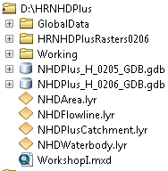

1. Make sure that you have ArcGIS installed. Version 10.5.1 was used to build this exercise. Earlier or later versions of ArcGIS should work. However, screen displays may vary.
2. Open ArcMap.
3. Open \HRNHDPlus\Workshop1.MXD and ensure that ArcMap has located all data in the table of contents. If not, return to step c above and confirm that your folder structure and naming is correct, and that you’ve downloaded/uncompressed all of the Workshop materials. Close ArcMap.
4. Open ArcCatalog and examine the data structure of the NHDPlus_H_0206_GDB.gdb, and the 10 rasters in HRNHDPlusRasters0206.

# **Create a Working ArcMap Document**

Typically, you’ll create an ArcMap document which contains the High Resolution NHDPlus data that you plan to use for your work. This section of the exercise walks you through adding, symbolizing and relating the data in VPU 0206.

1. Open ArcMap.
2. Right click on **Layers**. Select **Properties and the Coordinate System** tab. Set map projection to Albers by importing the projection as follows. Click the **Add Coordinate System** button  and select **Import.** Browse to and chose \HRNHDPlus\HRNHDPlusRasters0206\elev_cm.tif

(USA Contiguous Albers Equal Area Conic USGS version)

1. **Add Data:**

\HRNHDPlus\NHDPlus_H_0206.gdb\Hydrography\NHDFlowline. Symbolize with \HRNHDPlus\NHDFlowline.lyr.

\HRNHDPlus\NHDPlus_H_0206.gdb\Hydrography\NHDWaterbody. Symbolize with \HRNHDPlus\NHDWaterbody.lyr.

\HRNHDPlus\NHDPlus_H_0206.gdb\Hydrography\NHDArea. Symbolize with \HRNHDPlus\NHDArea.lyr.

1. Perform the following steps to symbolize each feature class with corresponding layers: Right click on feature class in the **Table of Contents** pane, and open the **Properties** dialog box. Click on the **Symbology** tab and select **Import**. Toggle to the HRNHDPlus folder and select the appropriate layer file. Click **Add**. Choose to import the **Complete Symbology Definition** and click **OK**. Accept defaults and click **OK.** Then click **Apply** and **OK** before closing the **Layer Properties** dialog box.

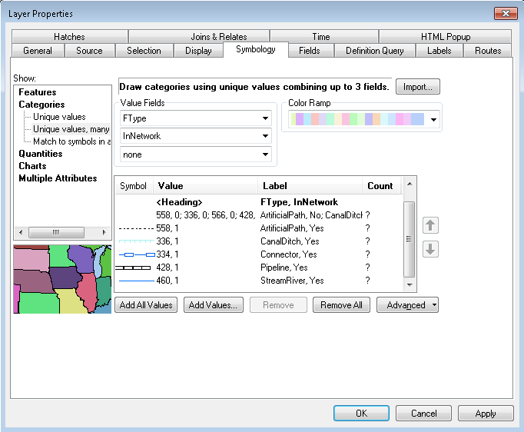

Note: NHDFlowlines with InNetwork = “No” are made invisible. This is because these flowlines are ones where the NHD is not sure of the direction of flow or where a flowline was intentionally removed from the network. Ultimately, these are not considered a part of the NHDPlus network. They receive no NHDPlus attributes and they do not get catchments.

1. **Join** NHDFlowline.NHDPlusID with \HRNHDPlus\NHDPlus_H_0206.gdb\NHDPlusFlowlineVAA.NHDPlusID. The VAA table contains many of the NHDPlus attributes. There is one record in the VAA table for each flowline with InNetwork = “Yes”.

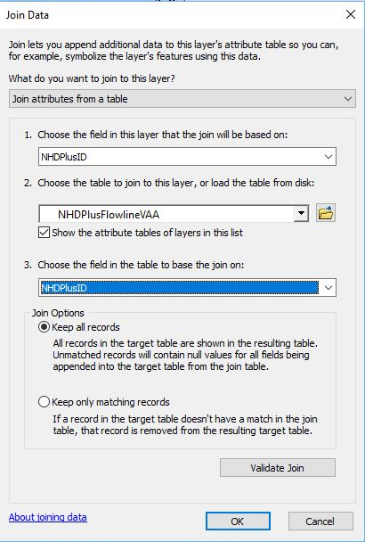

1. **Relate** NHDFlowline.WBArea_Permanent_Identifier to NHDWaterbody_Permanent_Identifier. Name the relate “Waterbody-WBAreaPermID.”

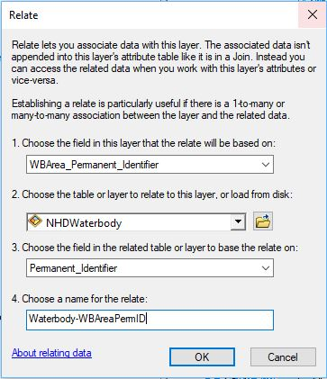

Note: this relates the NHDFlowline Artificial Path features to the NHDWaterbody features through which the Artificial Paths flow.

1. **Relate** NHDFlowline.WBArea_Permanent_Identifier to NHDArea.Permanent_Identifier. Name the relate “Area-WBAreaPermID.”

Note: This relates the NHDFlowline Artificial Path features to the NHDArea features through which the Artificial Paths flow.

1. **Add Data** \NHDPlus_H_0206.gdb\NHDPlus\NHDPlusCatchment. Symbolize with no fill and red edges.
2. **Relate** NHDPlusCatchment.NHDPlusID to NHDFlowline.NHDPlusID. Name the relate “Catchment-Flowline.”

Note: This links the flowline to the catchment which represents the immediate drainage area for the flowline.

1. **Add Data** \NHDPlus_H_0206.gdb\NHDPlusFlow. This is the NHDPlus flow table. There is a record in this table for each pair of flowlines that touch each other end-to-end.
2. **Relate** NHDPlusFlow.FromNHDPlusID to NHDFlowline.NHDPlusID. Name the relate “FromNHDPlusID.” This relate links the upstream flowline in a flow relationship to an NHDFlowline feature.
3. **Relate** NHDPlusFlow.ToNHDPlusID to NHDFlowline.NHDPlusID. Name the relate “ToNHDPlusID.” This relate links the downstream flowline in a flow relationship to an NHDFlowline feature.
4. **Relate** NHDPlusFlow.NodeNumber to NHDFlowline.ToNode. Name the relate “ToNode.”
5. Save the map project as \HRNHDPlus\Working\Student1.mxd. We will be using these relates in the following steps.
6. Click the **Zoom to XY** tool on the ArcMap Toolbar. Use the arrow pull down to change the units to Meters. Enter the coordinates below and click the **Zoom** button.

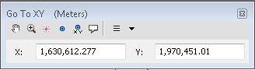

1. Set the Map Scale to 1:45,000. Select the NHDFlowline shown in the picture below, then open the NHDFlowline attribute table and NHDPlusFlow table.

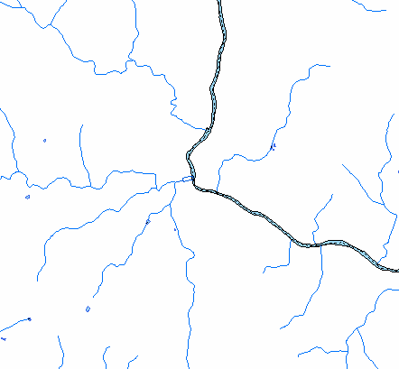

1. Click **Table Options** -> **Arrange Tables**  -> **New Horizontal Tab Group** and dsiplay only the selected records.

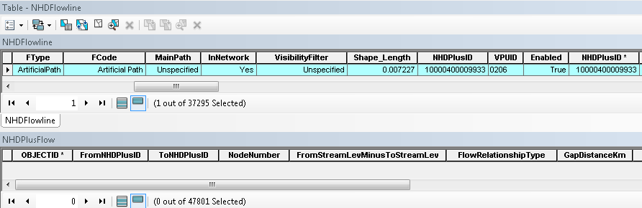

1. Using the relates between NHDFlowline and NHDPlusFlow, we’re going to walk down the network. Each time the following two steps are performed, the navigation in the NHDPlusFlow table will move down one flowline. Perform these steps 4 or 5 times and watch what happens. Note that when the navigation gets to the flow split, it continues down both paths progressing one flowline at a time along each path.
2. From the NHDFlowline attribute table, execute the FromNHDPlusID relate. This selects the NHDPlusFlow records where the selected flowline is the upstream or “from” flowline.

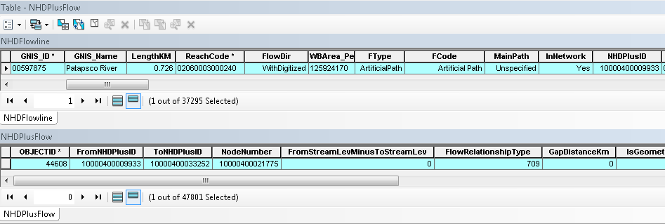

1. From the NHDPlusFlow table, execute the ToNHDPlusID relate. This selects the flowlines that are next downstream.

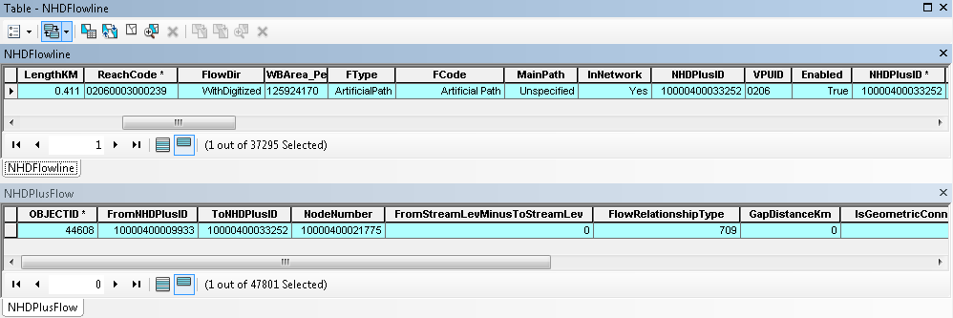

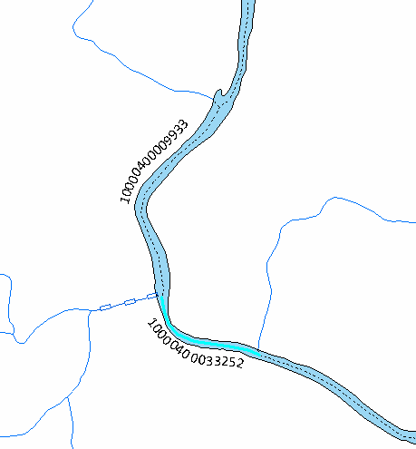

1. Repeat steps s and t several times and see how the downstream navigation using the NHDPlusFlow table works. Save the Student1.mxd and close ArcMap.

# **Add Raster Layers to an ArcMap Document**

There are 10 raster layers in each NHDPlus VPU.

The ***elev_cm***  raster is the original elevation data used to build HRNHDPlus, projected to the NHDPlus raster coordinate system. Elevation values are represented as integer centimeters. An attribute table is not created for this raster.

**shdrelief** is an integer raster generated from the elev_cm raster. As its name implies, it contains the shaded relief.

In each cell of the ***fac*** raster (a.k.a. flow accumulation) is the number of upslope cells that drain to that cell. The raster contains a skewed distribution of values. The vast majority of cells contain small numbers (less than 100), however the cells along major flow paths can have values into the hundreds of millions.

***fdr*** is the Integer flow direction raster which contains the codes that show the direction water would flow from each raster cell based on the HydroDEM. The raster has 8-bit, unsigned values.

The ***filldepth*** raster is the numerical difference between the hydrodem raster and a filled raster (not included in the final product). This raster is useful for examining the results of the hydro-conditioning process. The “burned and walled” raster before filling can be re-created by subtracting this raster from the hydrodem raster. The units of this raster are in cm (although some values are very large due to burn and wall values used in the processing). The raster attribute table for filldepth may not be created if the number of unique values is large.

The ***cat*** raster contains a unique gridcell value for each NHDPlus catchment. There are a large number of unique values. In most cases, it’s not necessary to see the records in the ***cat*** attribute table or to display the grid. All the same information is in the ***catchment***feature class attribute table, and can be used much more readily in that form. The ***cat*** raster is primarily useful for raster overlay analysis such as the Spatial Analyst’s Zonal Statistics tool. We’ll use the cat raster in the **Linking Data to the Network** section later in the exercise.

**catseed** is an integer raster which contains the seed cell for each catchment. The catchment gridcodes are stored in the seed cells. This raster is distributed as documentation of the raster processes used to build NHDPlus.

***fdoverland*** is the overland flow direction raster. This raster is created by taking the fdr raster and setting all cells coincident with the flow network or waterbodies to NoData.

***swnet*** contains the raster flow network. All cells besides cells on the flow network or on waterbodies are assigned a value of NoData.

**hydrodem** is an integer raster of the hydro-conditioned version of elev_cm, with all aspects of the NHDPlus burn components integrated and filled. This raster is used to generate the flow direction raster (fdr) from which the flow accumulation (fac) and catchment (cat) rasters are generated. The elevations are in centimeters. This grid is distributed to document the hydro-enforcement processes used to build NHDPlus.

1. Open the Student1.mxd from the previous section and save a copy as Student2.mxd
2. **Add Data** \HRNHDPlusRasters0206\shdrelief.jp2. If prompted, Click “Yes” to building pyramids.
3. Right click on the ShdRelief raster, choose **Properites** -> **Symbology.** Select **Stretched** as shown below, click **Apply** then **OK.**

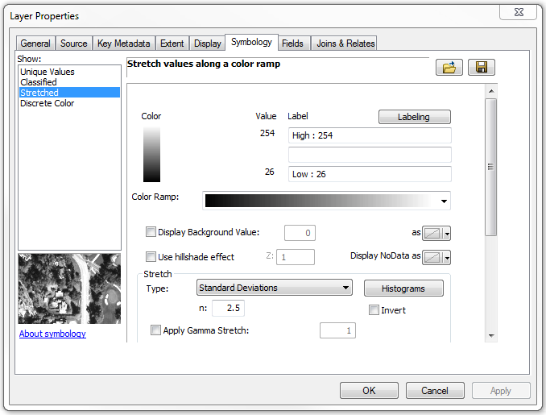

1. Turn off all layers except shdrelief. Right click on shdrelief and select **Zoom to Layer** and pan around**.** Then set the Map Scale to 1:24:000. Note the blocky nature of the display.
2. Double click on shdrelief (this is another way to open the layer properties dialog). In the layer properties, click **Display.** In the **Resample During Display** pulldown, select **Bilinear Interpolation** and click **OK.** Notice how the display looks smoother.

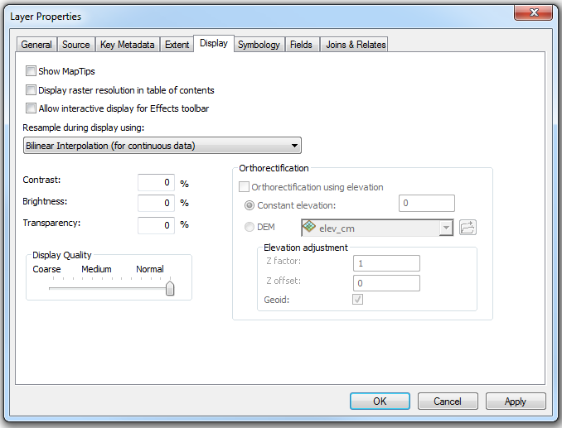

1. **Add Data** \HRNHDPlusRasters0206\elev_cm. Click “Yes” to building pyramids.
2. Open the elev_cm layer properties and click on the **Symbology** tab, make sure the **Strectched** option is highlighted. Right click on the black-to-white **Color Ramp** and click **Graphic View.** The check mark beside **Graphic View** should disappear and the text descriptions of the items in the **Color Ramp** should disappear in the pull down menu. From the **Color Ramp** pull down, select **Elevation # 1.**

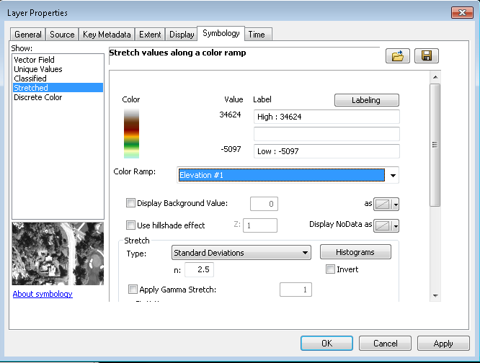

1. Select the **Display** tab and change the **Transparencey** to 50%. Click **OK.**
2. Set the **Map Scale** to 1:100,000. Notice the nice, shaded relief map created using the elevation layer draped over the shaded relief Layer

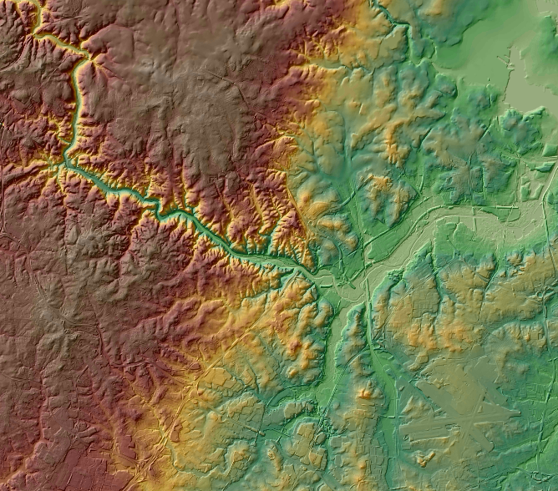

1. **Add Data** \HRNHDPlusRasters0206\fac. Say “Yes” to building pyramids.
2. Open the layer properties and change the renderer from **Stretched** to **Classified. Build Histogram,** if prompted.

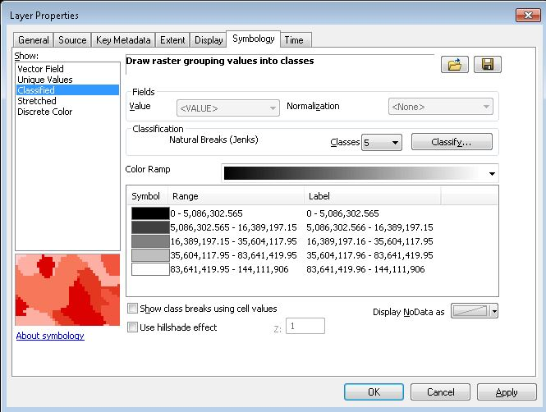

1. Click **Classify…** In the **Classification** window, change the number of **Classes** to 2 and change the first **Break Value** to 100. Click **OK.**

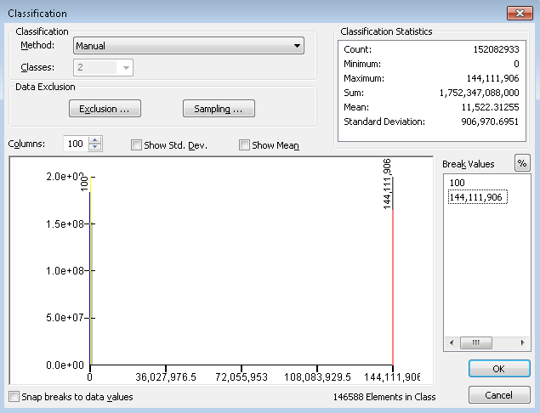

1. Back on the **Symbology** tab, double click on the black box under **Symbol** next to the 0-100 **Range,** then choose **No Color** in the color menu. Double click on the black box under **Symbol**  next to the 100-144,111,906, then choose a dark hue of purple in the color menu. Click **OK.**

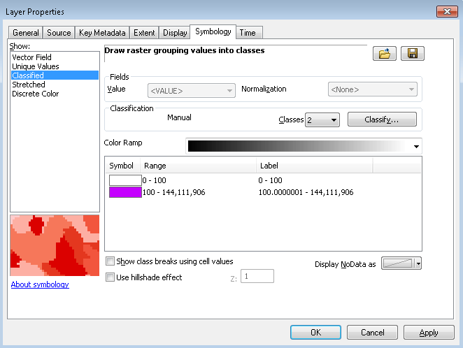

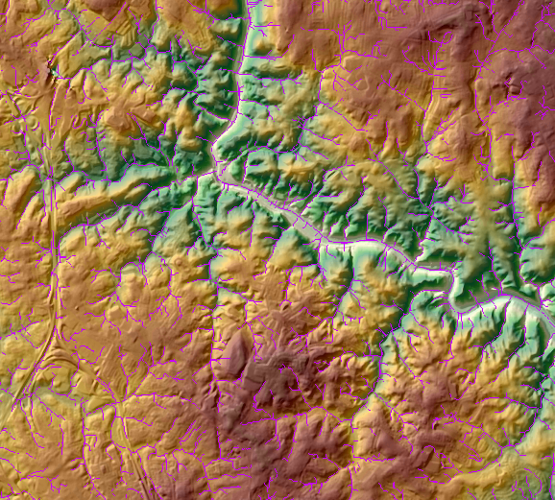

Note: The purple lines are made up of cells in the fac raster that have 100 or more cells upslope. These lines indicate where the drainage channels are on the HydroDEM. Turning off the elev_cm and shdrelief layers will enable you to see the channels better. These channels are sometimes referred to as synthetic streams because they are simply channels in the DEM which may or may not contain water. In general, where the channels and NHDFlowlines cooincide, the channels should follow the NHDFlowline features closely, since the networked NHDFlowline features were burned into the HyrdoDEM. The threshould of 100 is shown to illustrate the concept, but any threshold may be chosen.

1. Turn on the NHDFlowline layter and pan northwest to be able to see more NHDFlowline features. Note: The threshold of 100 creates many more channels (purple lines) than features in NHDFlowline (blue lines). Using a larger threshold would help make the synthetic lines more closely represent the NHDFlowline features.

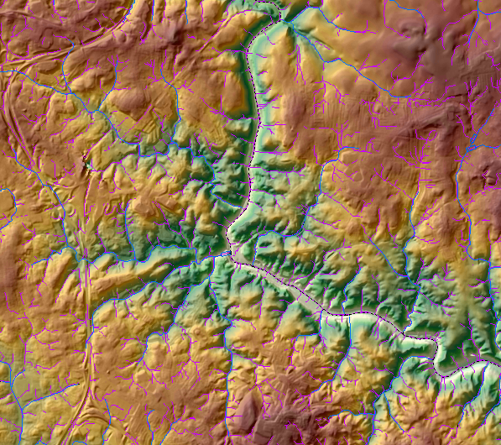

1. Let’s measure the distances from locations within a catchment to the flowline within the catchment. This is a task for the fdr raster. Be sure to have the **Spatial Analyst** extension turned on. You can check this by clicking the **Customize** menu in ArcMap, select **Extensions** and check the box next to **Spatial Analyst.**

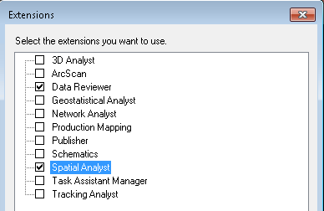

1. Open the **ArcToolbox** by clicking . Open the **Flow Length** tool under **Spatial Analyst** -> **Hydrology.** Fill in the tool parameters like this:

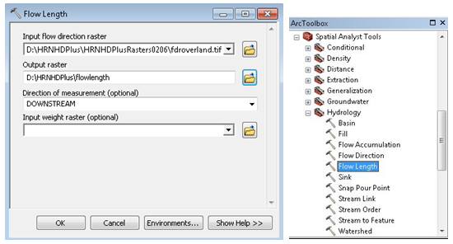

1. Click on **Environments…** and use the fdroverland raster to set the **Output Coordinate System,** the **Extent** and **Snap Raster.**

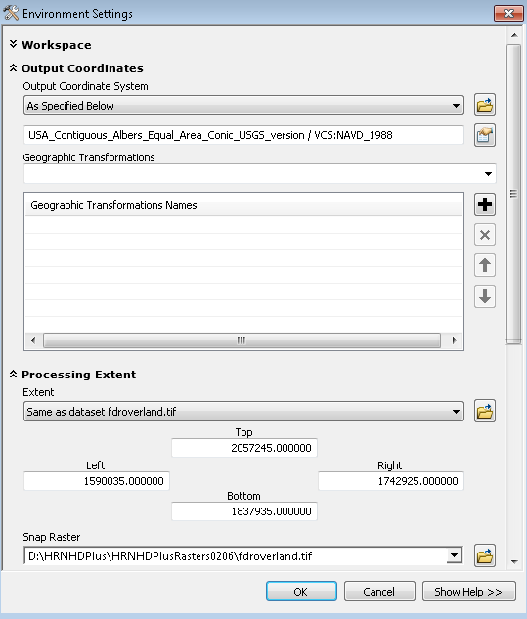

1. Click **OK** and **OK** again. The **Flow Length** tool could take as long as 30 minutes to run.
2. In the flowlength output raster, cells contain the length (in meters) of the downhill flow path from the cell to the flowline in the catchment. Zoom in and do an **Identify** on some of the cells.
3. At this point, we can use the **Zonal Statistics as Table** to compute the maximum flow path distance to water for each catchment. From the ArcToolbox, click **Spatial Analyst** -> **Zonal** -> **Zonal Statistics as Table.** Populate the tool fields as follows:

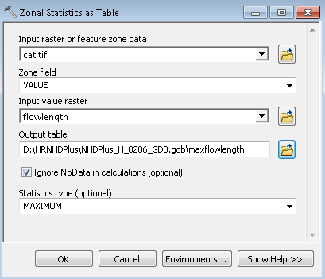

Note: The ‘VALUE’ field coincides with the GridCode field in the NHDPlusCatchment feature class.

1. The flowlength raster is displayed in the picture below. The white lines are the cells where the a value is 0, i.e. 0 path length to the flowline. In other words, the white cells represent the flowlines. The maxflowlength table is also shown. We can see that in the selected catchment, the maximum flow path distance to water is 1168.82251meters. There are many other interesting analyses that can be done with the fdr rasters.

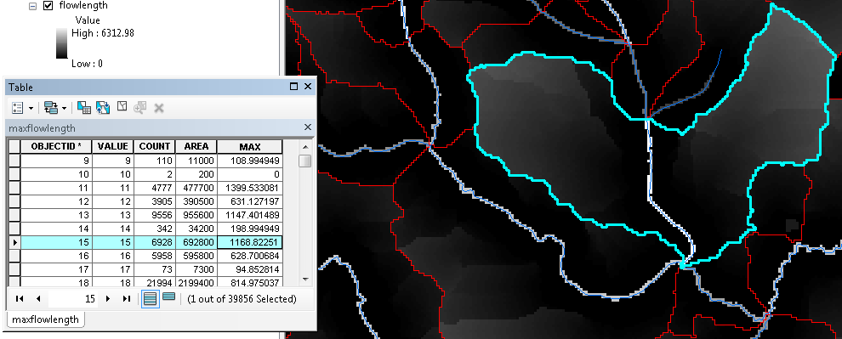

Save the Student2.mxd and close ArcMap.

# **Navigating the Network**

## Geometric Network Navigation

1. Open ArcMap and **Add Data:**

\HRNHDPlus\NHDPlus_H_0206_GDB.gdb\NHDFlowline. Symbolize with \HRNHDPlus\NHDFlowline.lyr

\HRNHDPlus\NHDPlus_H_0206_GDB.gdb\NHDWaterbody.

Symbolize with \HRNHDPlus\NHDWaterbody.lyr

\HRNHDPlus\NHDPlus_H_0206_GDB.gdb\NHDArea.

Symbolize with \HRNHDPlus\NHDArea.lyr

Set the data frame coordinates to USA Contiguous Albers Equal Area Conic USGS version and save the map project as Student3.mxd

1. Create a permanent join between NHDFlowline and the NHDPlusFlowlineVAA table. Be sure to use NHDPlusID as the join field. **Data Management** -> **Joins** -> **Join Field**.

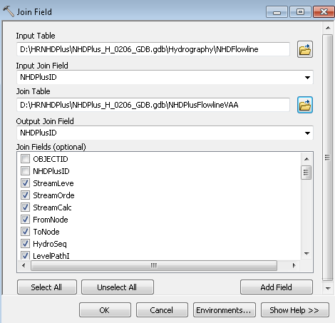

1. Using the same method, create another permanent join between NHDFlowline and the NHDPlusEROMMA table. In the **Join Fields** box, unclick all EROMMA fields except for QAMA, QEMA, VEMA, QGAdjMA. Click **OK.** These are the only EROM attributes that will be used in the following navigation and analysis activities.
2. From the ArcToolbox, select **Data Management** -> **Geometric Network** -> **Set Flow Direction** to establish the flow direction as being **WITH_DIGITIZED_DIRECTION** of the NHDFlowlines.
3. Open the **Zoom to XY** tool, found on the ArcMap Toolbar. Use the arrow pull down to change the units to Meters. Enter the coordinates shown below and click the **Zoom** button.



1. Create a bookmark for this location. Click the **Bookmarks** menu and select **Create Bookmarks.**
2. From the Utility Analyst Toolbar, use the **Edge Flag** () tool and place a flag on the NHDFlowline near this location. Note: To remove an unwanted flag, click the **Analysis** dropdown menu and select **Clear Flags.**

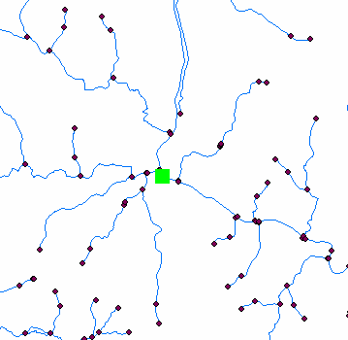

1. From the Analysis pulldown, select **Options** -> **Results.** Select **Return Results as Selection.** Then click the **Trace Tasks** pulldown and select **Trace Upstream.**



1. Click the **Solve** () button and zoom to the selected features.

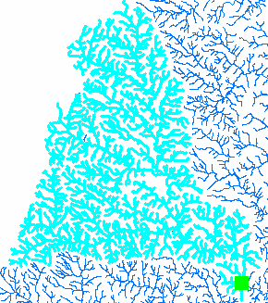

## Using Weights in the Geometric Network

1. Click the catalog button  to add the ArcCatalog tree to ArcMap. From there, right click on NHDPlus_H_0206_GDB.gdb\Hydrography\HYDRO_NET and select **Properties** -> **Weights.**
2. Click **New** and call the new weight StreamFlow, type Double.
3. In the pull down next to NHDFlowline, select QEMA (i.e. gage-adjusted stream flow). Click **OK.** Note: Applying the weight could take a few minutes**.**

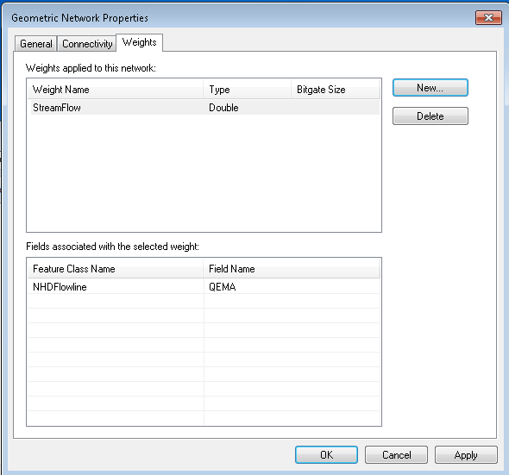

1. In the Utility Network Analyst Toolbar, click on **Analysis** -> **Options** -> **Weights** tab. Under **Edge Weights** -> **Weight Along Digitized Direction** and **Weight Against Digitized Direction of Edge,** select **StreamFlow in the pulldown.**

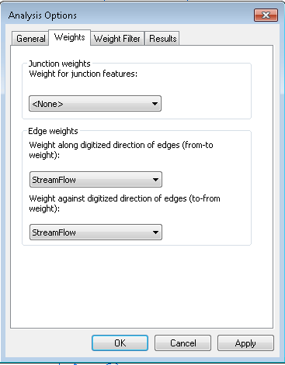

1. On the **Weight Filter** tab, under **Edge Weight Filter** -> **From – To Weight** and **To- From Weight,** select StreamFlow and in **Weight Range** put 0 -50 and place a check mark next to **Not.** Click **Apply,** then click **OK.**

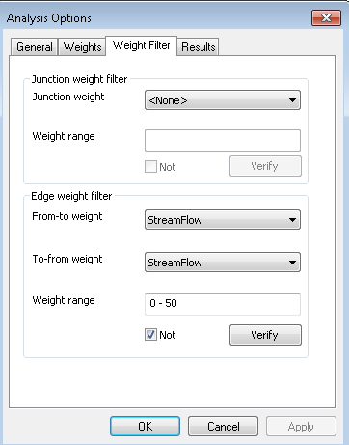

1. Place an **Edge Flag** on one of the flowlines in this area (make sure it has GNIS_Name = Patapsco River).
2. Under the **Results tab,** make sure **Return results as Selection** is checked. Click **OK.**
3. Click the **Solve** button (). Only flowlines with Streamflow > 50 are navigated.

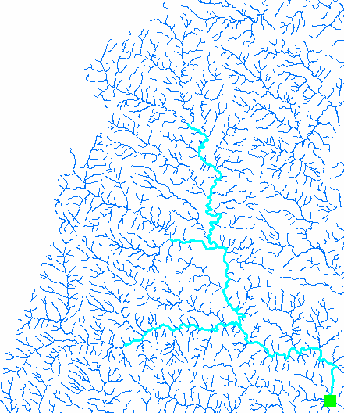

Note: Any attribute in your junctions or network edges can be added as a weight and used to control navigation.

## Navigating with Network Attributes

* 1. Navigating *Upstream Mainstem* is relatively easy. Open the NHDFlowline table options and turn on LevelPathI, Hydroseq, DnLevelPat and DnMinorHyd. Then select the level path of the Patuxent River (LevelPathI=10000400000044). This will select 378 flowlines from where the Patuxent River discharges into the Chesapeake Bay to the top of this level path. This is an Upstream Mainstem.
  2. To navigate *Upstream with Tributaries* from the bottom of a level path is more complex and requires an iterative process.
     1. Starting with the Mainstem navigation from above, Export the selected NHDFlowlines (For the Patuxent River’s LevelPathI = 10000400000044) to \HRNHDPlus\NHDPlus_H_0206_GDB.gdb\Hydrography\NavResults1
     2. This iterative process involves performing a **Select By Attributes** query on NHDFlowline. Enter the following text in the **Select By Attributes** dialog:
     3. “DnLevelPat” in (SELECT “LevelPathI” FROM NavResults1) OR “DnMinorHyd” in (SELECT “Hydroseq” FROM NavResults1)

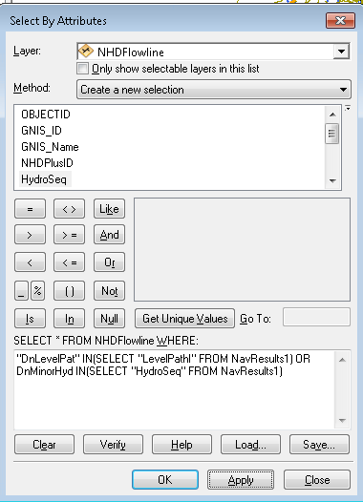

This selection statement above involves a SQL sub-query, which only works on geodatabase features classes. This code will*not* work on shapefiles.

The query is looking for any records from NHDFlowline whose “DnLevelPat” value is also located in the “LevelPathI” field in the NavResults feature class, OR any records from NHDFlowline whose “DnMinorHyd” value is also located in the “Hydroseq” field from NavResults1.

Basically, since NavResults1 is the mainstem of the Patuxent River, this Select By Attributes query is looking for any tributaries in NHDFlowline that flow into that mainstem.

* 1. Compare the number of selected records in NHDFlowline to the number of records in NavResults<m>. Note: the first time through this procedure substitute 1 for <m>, then next time through this procedure substitute 2 for <m>, then 3 and so on.
     1. If the number of selected records in NHDFlowline is less than or equal to the number of records in NavResults<m>, then the process ends because all of the waters have been found that flow into flowlines that have already been navigated.
     2. If the number of selected records in NHDFlowline is greater than the number of records in NavResults<m>, then the Upstream with Tributaries navigation is still finding new waters that into flowlines that have already been navigated.
     3. Export the selected NHDFlowline records to a new geospatial feature class called \HRNHDPlus\NHDPlus_H_0206_GDB.gdb\Hydrography\NavResults<m+1>
     4. So the file name should be NavResults2 the first time through this step, then NavResults3 next time, etc.
     5. When prompted, add NavResults<m+1> to the map.
  2. Incremented the value of m by 1, substitute m’s new value for <m> in the query below. Cut and past the query into a new **Select by Attributes** from NHDFlowline.
     1. "DnLevelPat" IN(SELECT "LevelPathI" FROM NavResults<m>) OR DnMinorHyd IN(SELECT "HydroSeq" FROM NavResults<m>)
     2. The query is looking for any records from NHDFlowline whose “DnLevelPat” value is also located in the “LevelPathI” field in the NavResults<m> feature class, OR any records from NHDFlowline whose “DnMinorHyd” value is also located in the “Hydroseq” field from NavResults<m>.
     3. Basically, each time the Select By Attributes is performed, another level of tributaries is added to the select. We started with the Patuxent River main stem, then added the tribs to the Patuxent, and then added the tribs to the tribs, and so on until we reach the top of the network that drains into the Patuxent River.
     4. After the query is executed, go to Step c and repeat steps c and d.
  3. The final result of this *Upstream with Tributaries*  navigation looks like this:

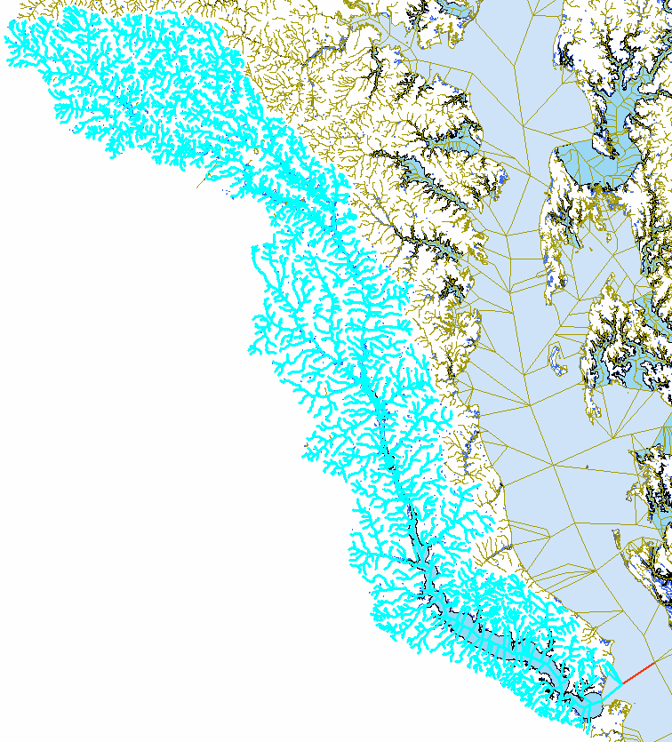

Save the Student3.mxd and close ArcMap.

Homework assignment: Develop the steps necessary to perform the following navigations:

1. Upstream with Tributaries beginning in the middle of the Patuxent River (i.e. up the Patuxent River level path).
2. Downstream mainstem from the top and middle of the Patuxent River.
3. Downstream with Divergences from the top and middle of the Patuxent River.

There is an NHDPlus desktop tool that performs all of these VAA navigations from an ArcMap toolbar. This navigation performs point-to-point navigations and has many options. The tool is callable from Python. The High Resolution NHDPlus VAA Navigator is available on the NHDPlus HR website.

# **Put Network Attributes to Work**

We’re now going to do some interesting things with the Flowline network and NHDPlus Flowline attributes.

## Add Waterbody attributes to NHDFlowline Artificial Path Features

1. Open the Student3.mxd from the previous section. Then save a copy as Student4.mxd.
2. If it’s not already loaded, add the **Editor** toolbar to ArcMap and start an editing session.
3. From the ArcToolbox, add two fields using **Data Management** -> **Fields** -> **Add Field.** We want to add fields to NHDFlowline called WBFType Text(24) and WBSize Double.

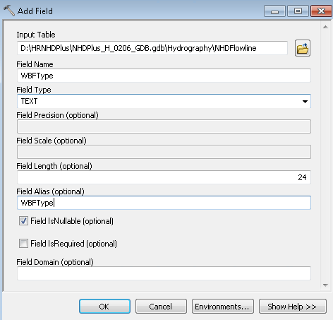

1. Open the NHDFlowline attribute table.
2. From **Table Options,** select **Join->** NHDFlowline.WBArea_Permanent_Identifier to \HRNHDPlus\NHDPlus_H_0206_GDB.gdb\Hydrography\NHDWaterbody.Permanent_Identifier.
3. Populate the NHDFlowline WBFType field using the **Field Calculator.** Right click on WBFtype, select **Field Calculator** and double click on NHDWaterbody.FType and click **OK.** (If prompted, say “yes” to warning messages. Note: make sure to calculate the field using NHDWaterbody FType, *not* NHDFlowline FType.)
4. Using the same method, populate the NHDFlowline.WBSize field, and use the NHDWaterbody.AreaSqKM field as the input. (If prompted, say “yes” to any warning messages.)
5. Remove the join to NHDWaterbody.
6. Right click on WBFtype and **Sort Descending**. Take note that now the Artificial Path NHDFlowline features are inside NHDWaterbodies, such as Lake/Pond features. This will enable us to identify these waterbody features when we navigate. Note also that Artificial Path features inside NHDArea features do not have WBFType or WBSize populated.

## Find all the tributaries in the Patapsco River

1. Use the **Go To XY** tool on the ArcMap toolbar and zoom to the coordinates pictured below. This is the mouth of the Patapsco River.

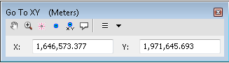

1. Use the **Identify** tool to display the NHDFlowline attributes for the most downstream flowline. Note that the LevelPathIdentifier is 10000400000474. This is a unique ID that defines the main path from the mouth of the Papapsco River to the main headwater flowline.

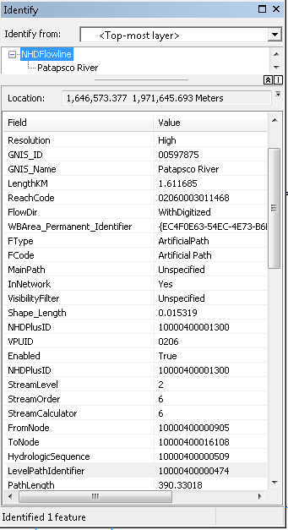

1. To see the entire water course, from the mouth of the Patapsco River to the main headwater, do a select “LevelPathI” = 10000400000474 and zoom to selected.

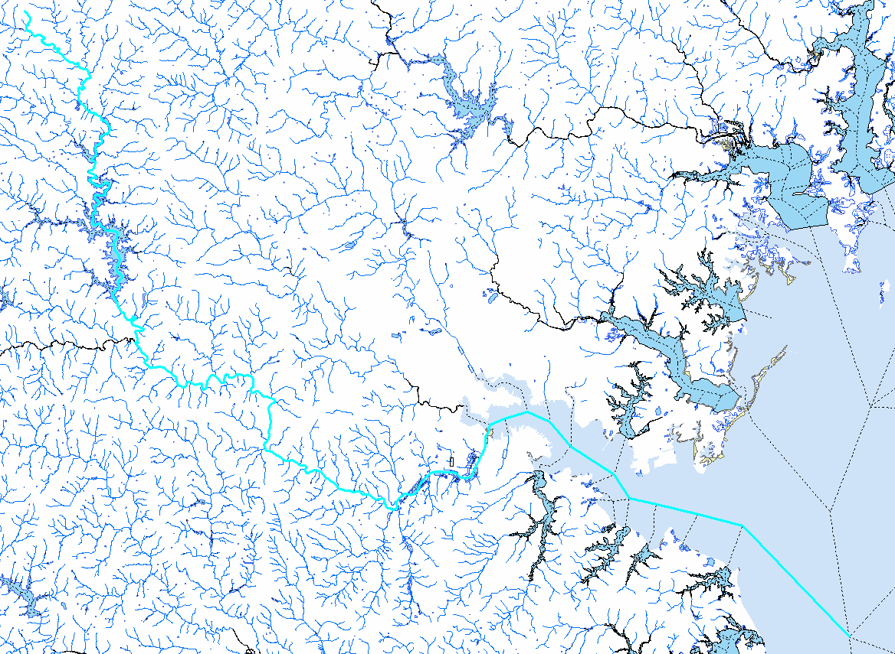

1. To see just the entire Patapsco River, do a select “LevelPathI”= 10000400000474 AND “GNIS_ID”= ’00597875’. Right click on NHDFlowline and **Zoom to Selected**.

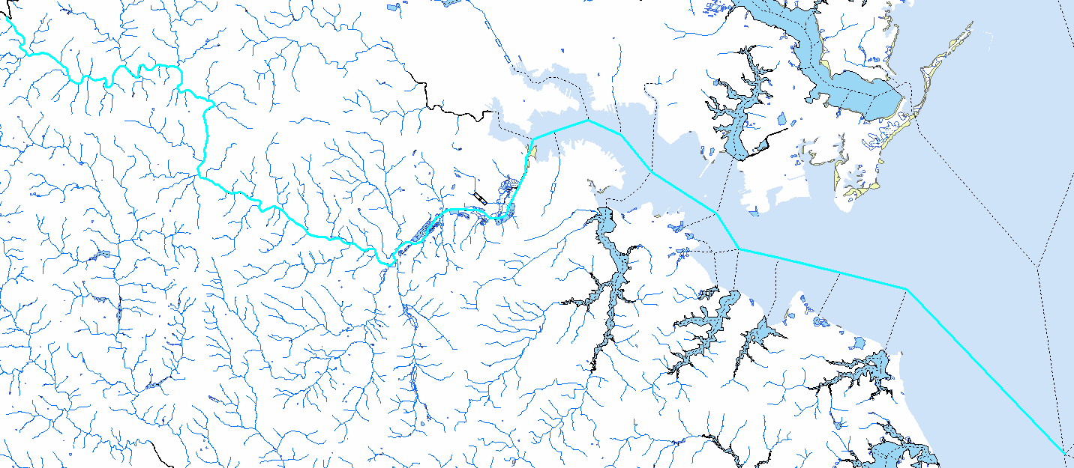

1. Note that when zooming to a named stream it’s always best to use the GNIS_ID rather than the GNIS_Name. This is because the GNIS_ID is a unique identifier for the named feature and if there are multiple streams with the same name (e.g. Mill Creek is a very popular name), each named stream has a unique GNIS_ID.
2. Find the tributaries to the Patapsco River: Open the NHDFlowline attribute table, and display the selected records. Sort ascending on Hydrologic Sequence (Hydroseq). Record the minimum and maximum Hydrologic Sequence of the Patapsco- 10000400000474 and 10000400001357.
3. To find the tributaries, perform a selection as follows:

“DnLevelPat” = 10000400000474 AND “DnHydroseq” >= 10000400000474 AND “DnHydroseq” <= 10000400001357 AND “GNIS_ID” <> ‘00597875’

1. In English, this statement says, select any NHDFlowline features whose immediate downstream flowline is the Patapsco River and whose downstream hydroseq is greater than or equal to the minimum hydroseq on the Patapsco and whose downstream hydroseq is less than or equal to the maximum hydroseq on the Patapsco and which is not the Patapsco itself.

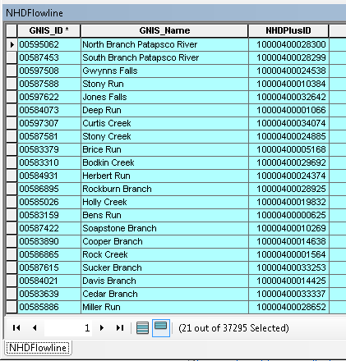

1. And we find that there are 21 tributaries to the Patapsco River in High Resolution NHDPlus.
2. Save the Student4.mxd

## How Many Lakes are along the Choptank River? How far are the lakes from the mouth of the Choptank River? How far apart are the lakes from each other?

Let’s find out.

1. Find the Choptank River by opening the attribute table, and selecting LevelPathI = 10000400000114 AND GNIS_ID = ‘00213797’. Zoom to selected.

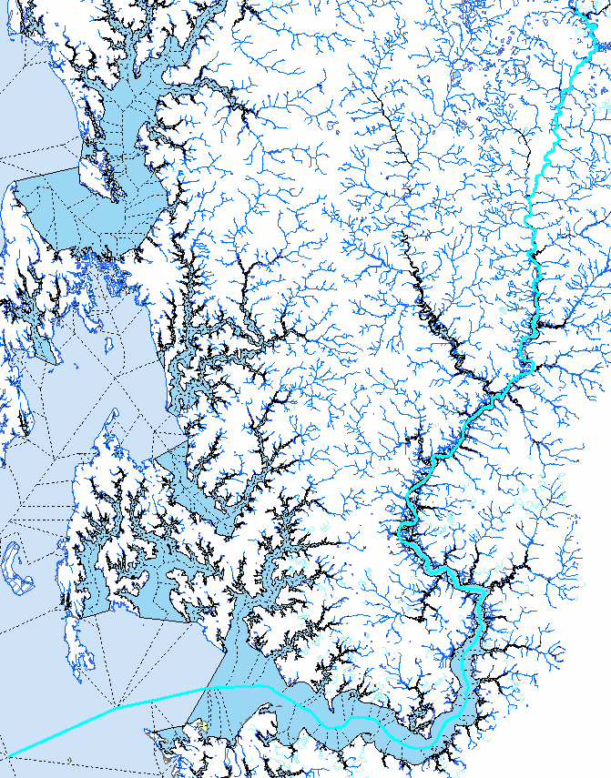

1. Zoom in to the mouth of the Choptank River and do an **Identify** on the most downstream flowline. Make note of the PathLength (306.725155). This is the distance from the mouth of the Choptank and to the bottom of the **Chesapeake Bay.**

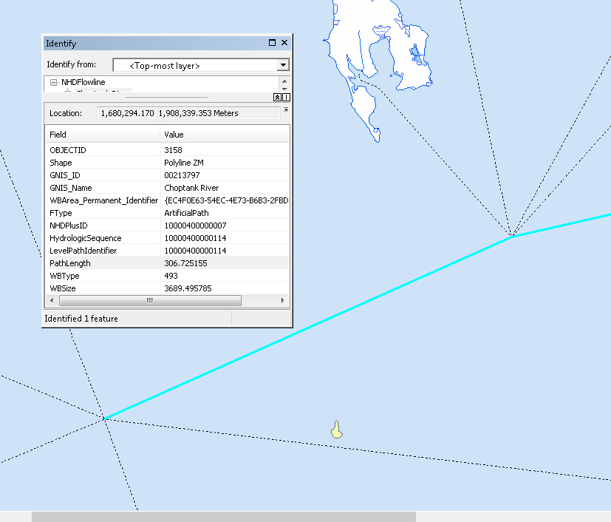

1. To find the lakes on the Choptank River, start with the following selection from NHDFlowline:

LevelPathI = 10000400000114 AND GNIS_ID = ‘00213797’AND WBFType = ‘390’. There are 13 NHDFlowlines inside lake features along the Choptank.

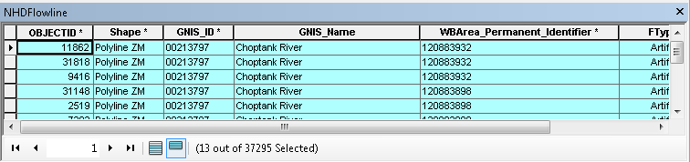

1. Determine the lake outlets. Right click on the NHDFlowline table WBArea_Permanent_Identifier and **Summarize** computing minimum Hydroseq and minimum Pathlength creating a table… \HRNHDPlus\NHDPlus_H_0206_GDB.gdb\LakeOutlets.

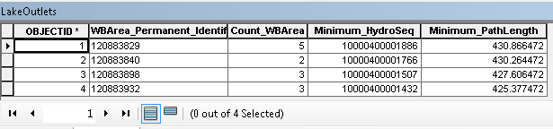

1. There are 4 lakes on the Choptank River. Each lake’s outlet is the NHDFlowline that has the Hydroseq value in the Minimum_Hydroseq column.
2. Open LakeOutslets table. From **Table Options, Joins and Relates** -> **Relate,** relate LakeOutlets.Min_HydroSeq to NHDFlowline.HydrologicSequence. Assign a name to the Relate if you wish. Select all LakeOutlet records and execute the Relate. Highlight the last selected NHDFlowline and **Zoom to Highlighted.** Perform an **Identify** on the lake. This is the outlet of the lake.

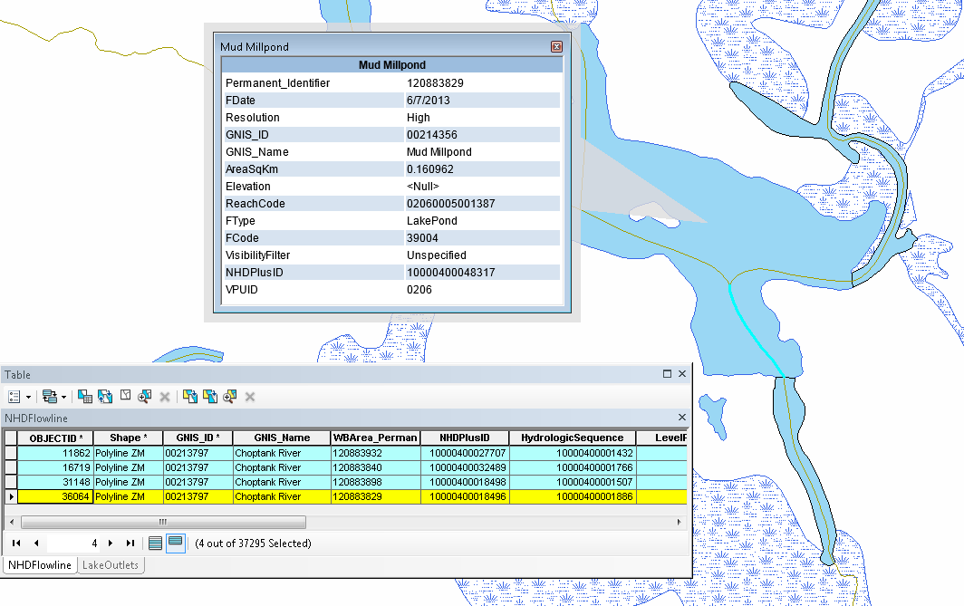

1. For LakeOutlets, **Table Options, Add Field ->** RiverKM double. Right click on RiverKM and use the **Field Calculator** set it to (Minimum_Pathlength - 306.725155).

PathLength is the distance from the bottom of the NHDFlowline feature to the network terminus and, in this case, the bottom of the Chesapeake Bay. Remember from above that 306.725155 is the PathLength for the mouth of the Choptank River. Therefore, RiverKM now contains the distance of the mouth of the Choptank for each of the 4 lakes. And, of course, by subtracting any two values in this column, we know how far apart the outlets of the lakes are from each other.

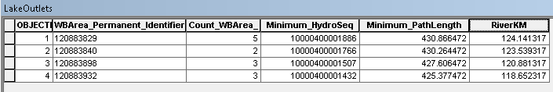

Save the Student4.mxd

## Make a profile plot of stream flow in the Patuxent River.

1. From NHDFlowline, select the flowlines for the Patuxent River -- GNIS_ID ='00597880' AND LevelPathI =10000400000044
2. Open NHDFlowline **Properties** -> **Fields.** Turn off all the fields except NHDPlusID, GNIS_ID, GNIS_Name, PathLength, QAMA, QEMA, and QGAdjMA. Note: QAMA values are flow from runoff estimates and QEMA values are for flow after gage adjustments (i.e. NHDPlus’ best flow estimate).
3. Export the selected NHDFlowline records to PatuxentAttributes.dbf
4. Open Excel.
5. Open \HRNHDPlus\PatuxentAttributes.dbf in Excel Make sure to show ‘All Files’ so Excel will recognize the dbf.

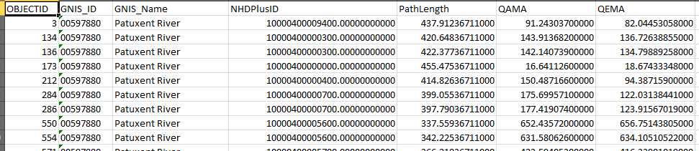

1. Sort PathLength in column E from smallest to largest.
2. Highlight columns F and G, right click and select format cells. Change the decimal places to 3.
3. Highlight all the values 1 to 379 in the columns for PathLength, QAMA and QEMA.
4. Click **Insert** -> **Charts** -> **Scatter Chart.** Select one with lines connecting the points (the second

choice).

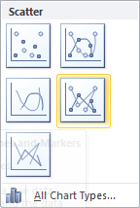

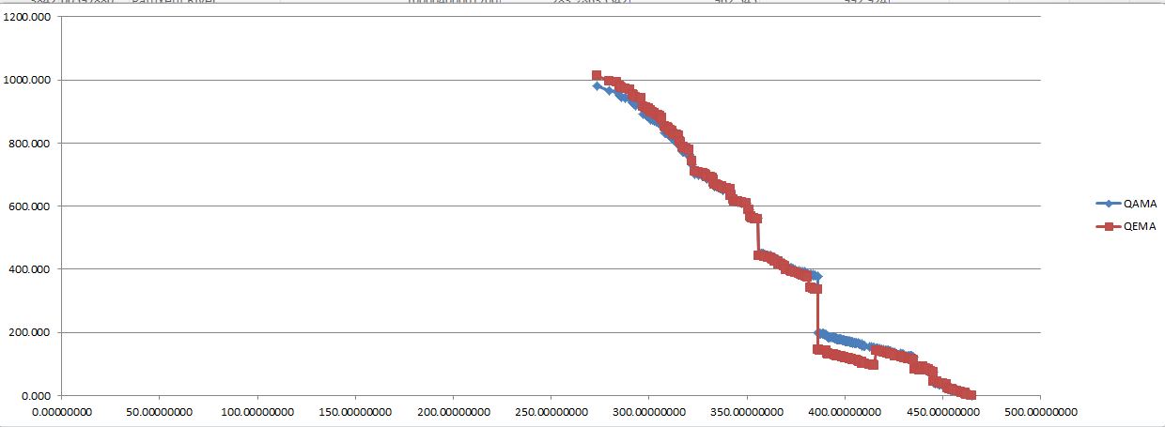

1. The chart x axis is the mouth (on the left) to headwaters (on the right). Notice the places where the flow QAMA or QEMA have large changes in value. For example, from the Excel chart we see one around a PathLength of 385
2. Return to ArcMap. Add a baselayer map by clicking **Add Data** -> **Add Basemap.** Select the USGS Topo. Ignore the “Geographic Coordinate Systems” warning by clicking **OK.** In the NHDFlowline table, sort the PathLength column by ascending.
3. Scroll down to approximately 435 in the PathLength column. Highlight the flowline where the large change in QAMA value (flow volume) occurs. (NHDPlusID 10000400018755).

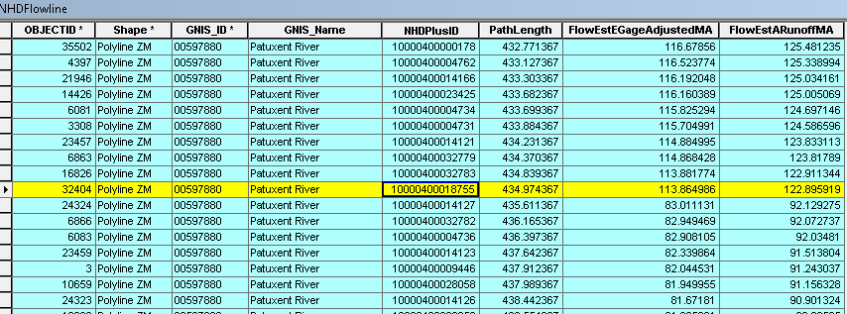

1. Zooming to the highlighted flowline, we see this is where Hawlings River discharges into the Patuxent.

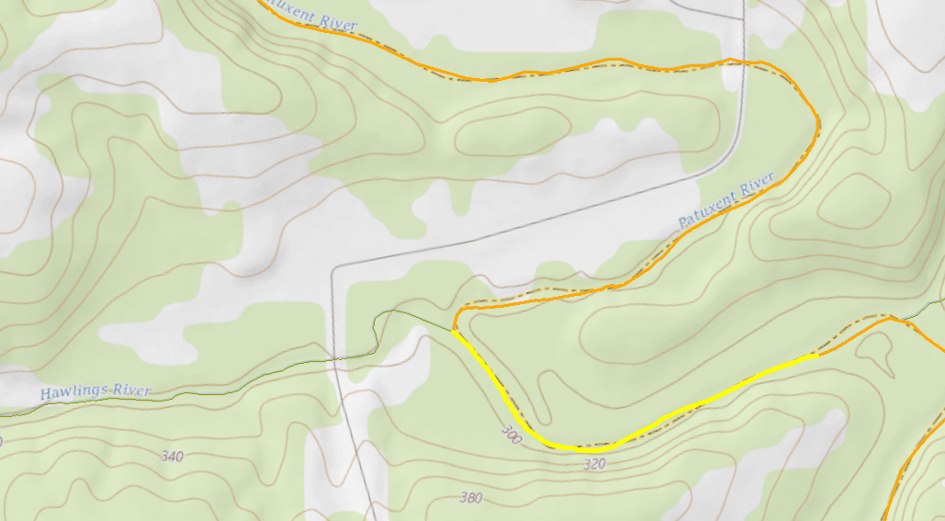

1. Back to the Excel plot, we see another extreme flow change around PathLength 350. Zoom to the highlighted flowline below.

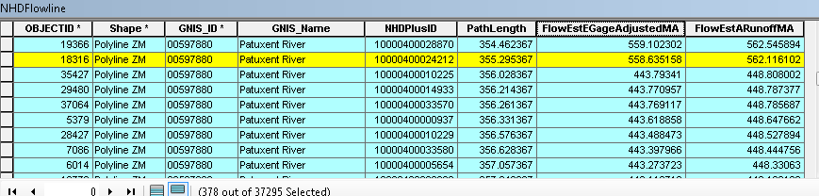

1. If we zoom in, we see that this is where the Western Patuxent River discharges into the Patuxent.

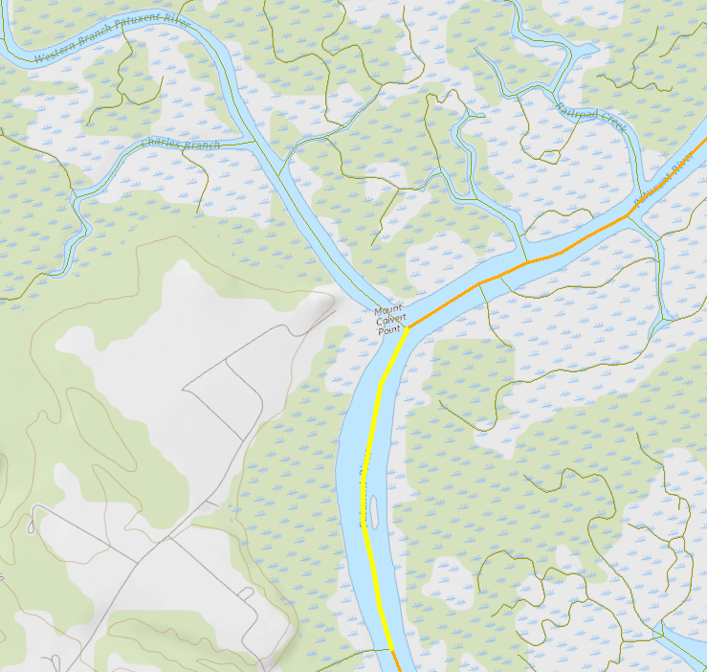

Save the Student4.mxd and close ArcMap.

# **Link Information to the Network**

During this section of the exercise, we’re going to create point and line events that link to the NHD/NHDPlus network. Events use NHDFlowline Reachcodes and the measure values imbedded in the NHDFlowline coordinates to link external information to a point along the network or a linear section of the network.

A point event is linked to a Reachcode and a measure. A line event is linked to a Reachcode, a from-measure (the starting endpoint of the event) and a to-measure (the ending endpoint of the event).

Note that measures along the one or more flowlines that have a given Reachcode begin at 0 at the downstream end of the Reach and stop at 100 at the upstream end of the Reach. The NHD convention is to express line events using the downstream measure as the from-measure and the upstream measure as the to-measure.

Events are entries in a table without geometry. The events can be rendered (and saved as a feature class) by using the ArcGIS Linear Referencing Toolbox. The event geometry comes from the NHDFlowlines based on the Reachcode and measure values.

1. Open ArcCatalog.
2. Create a new feature dataset: Right click on \NHDPlus_H_0206_GDB.gdb\ and select **New** -> **Feature Dataset…** Call it **Events** and use GCS_North_American_1983 as the coordinate system. Click Next to the following 2 screens and accept the defaults.
3. Create a point feature class for point events:
   1. Right click on \NHDPlus_H_0206_GDB.gdb\Events and select **New** -> **Feature Class**.Call the feature class **MyPoints.** Set **Type** to **Point Features.** Click **Next.**
   2. Accept defaults for the database configuration set up. Click **Next.**
   3. Add the following fields:

EventID (Text, 20)

EventDesc (Text, 100)

NHDPlusID(Double)

* 1. Click **Finish**.

1. Create a line feature class for line events:
   1. Right click on \NHDPlus_H_0206_GDB.gdb\Events and select **New** -> **Feature Class**. Call the feature class **MyLines,** Set **Type** to **Line Features.** Click **Next.**
   2. Accept defaults for the database configuration set up. Click **Next.**
   3. Add the following fields:

EventID (Text, 20)

Reachcode (Text, 14)

FromMeas (Double 9, 5)

ToMeas (Double 9, 5)

EventDesc (Text, 100)

NHDPlusID (Double)

* 1. Click **Finish**

1. Create a point feature class for the line event endpoints. Event endpoints will be used to determine the beginning measure and ending measure of the line events.
   1. Right click on \NHDPlus_H_0206_GDB.gdb\Events and select **New** -> **Feature Class…** call it **MyLineEndPoints, Type** -> **Point Features.** Click **Next.**
   2. Accept defaults for the database configuration set up. Click **Next.**
   3. Add the following fields:

EventID (Text, 20)

WhichEnd (Text, 1)

1. Close ArcCatalog.
2. Open ArcMap, set the data frame coordinate system to USA Contiguous Albers Equal Area Conic USGS version. Save the map project as Student5.mxd
3. **Add Data** \HRNHDPlus\NHDPlus_H_0206_GDB.gdb\Hydrography\NHDFlowline.
4. Create some point events:
   1. **Add Data** \HRNHDPlus\NHDPlus_H_0206_GDB.gdb\Events\MyPoints
   2. Add the **Editor** toolbar, if necessary.
   3. From the **Editor** toolbar pulldown, select **Snapping** and place a checkmark next to **Snapping Toolbar.** From the **Snapping Toolbar**, make sure Point, End and Vertex snapping are enabled. 
   4. From the **Editor** toolbar pulldown, select **Start Editing** -> **Editing Windows** -> **Create Features.**
   5. From the **Create Features** window, select **Editing Windows,** select **MyPoints.**

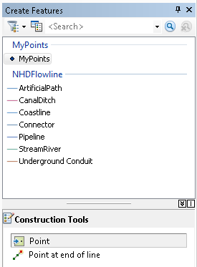

* 1. Use the **Map Scale** window to zoom in to about 1:150,000 scale somewhere in the NHDFlowline layer.
  2. Click on **Construction Tools**, then **MyPoints** in the **Create Features** window. Point to and click on NHDFlowline features creating points where you would like to have events. Populate the **EventID** field with a unique value for each point. Optionally, populate the EventDesc field.
  3. From the **Editor** toolbar, **Save Edits** and **Stop Editing.**
  4. Open the **ArcToolbox** -> **Linear Referencing Tools,** and open the **Locate Features Along Routes**. Fill in the dialog as follows:

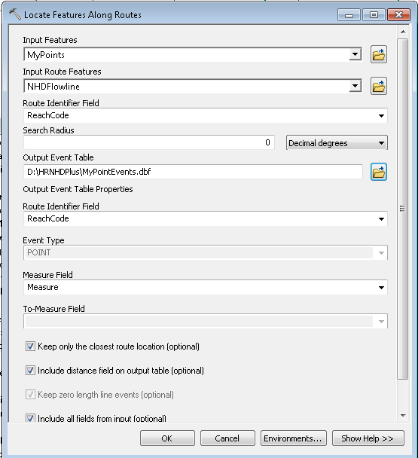

This creates an event table called **MyPointEvents** and adds it to the map. Open the attribute table and note that the NHDFlowline Reachcode and Measure location for each point have been added to the table.

* 1. To render the events in the map, open the **Linear Referencing** -> **Make Route Event Layer** tool and fill out the dialog as follows:

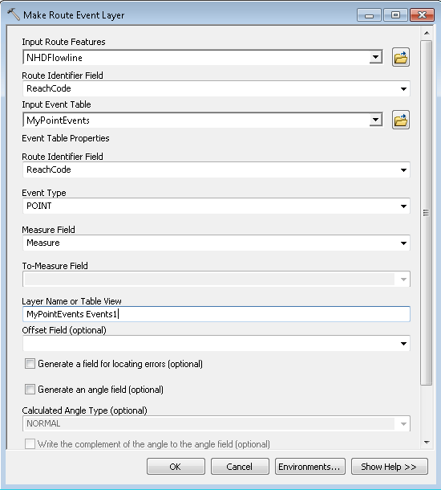

This creates a temporary layer in the map called **MyPointEvents Events1.** To permanently save the point events with their geometry, export the layer to **\NHDPlus_H_0206_GDB.gdb\Events\MyPointEvents_Rendered.**

* 1. Remove all the point and point event tables and layers from the map, leaving just NHDFlowline.

1. Create some line events:
   1. **Add Data** \NHDPlus_H_0206_GDB.gdb\Events\MyLineEndPoints and \NHDPlus_H_0206_GDB.gdb\Events\MyLines to the map.
   2. Add the **Utility Network Analyst** toolbar to ArcMap if necessary.
   3. From the **Utility Network Analyst** toolbar, use the **Analysis** pulldown and select **Options.** On the **Results** tab, select **Return Results as Selection.** Click **OK.**
   4. Start an editing session.
   5. From the **Create Features** window, select **MyLineEndPoints.**
   6. Point to and click on NHDFlowlines to create a bottom point and a top point for your event. By convention, the bottom point should be downstream of the top point. The end points may be on different flowlines. Open the **MyLineEndPoints** table and populate the WhichEnd field with “B” for Bottom and “T” for Top.
   7. Populate the EventID for both the Bottom and Top points with the same unique identifier.
   8. From the **Utility Network Analyst** toolbar, select the **Add Edge Flag** tool . Place an edge flag over your bottom point and another over your top point. From the **Choose Trace Task** pulldown, select **Find Path.** 
   9. Click the **Solve** button.  The flowlines between your bottom and top points are selected.
   10. Use the **Data Management** -> **General** -> **Append** tool as follows:

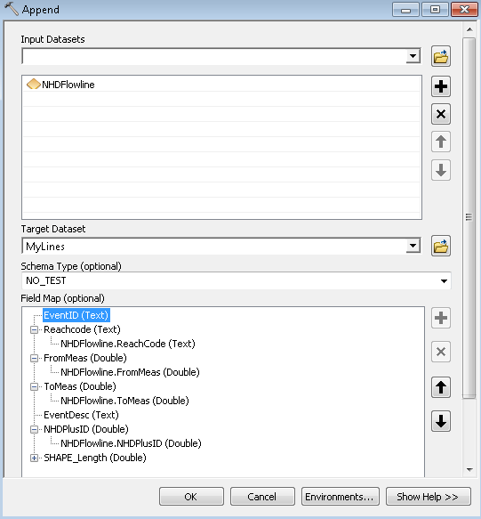

* 1. From the **Editor** toolbar, click **Save Edits.**

Note that the selected flowlines from the **Find Path** solution are now in your MyLines feature class.

* 1. Calculate the EventID for those records to the EventID you used for the Bottom and Top points.
  2. You may want to continue to create line events by repeating the process above. When you are finished, continue on with the instructions below.
  3. Use the **Linear Referencing** -> **Locate Features Along Routes** to obtain the exact measure values of your Bottom and Top points as follows:

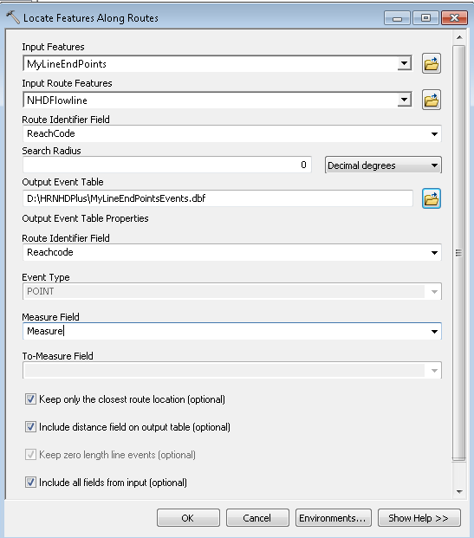

* 1. Open the MyLines table. This contains the lines between the Bottom point and the Top point of the linear events.
  2. Open the MyLineEndPointsEvents table. These are the Bottom and Top points of the new linear events.
  3. If you created more than one line event, you may have two or more line events on a given reach. Therefore the unique id for each Reachcode/event combination in MyLines and MyLineEndPointsEvents is a combination of Reachcode and EventID. To make a join on two fields, one easy way is to combine the field into one field called ComboKey:

**Add field** MyLines.ComboKey (Text, 34). Use **Field Calculator** set ComboKey to [Reachcode] & “ “ & [EventID]. This creates a unique ComboKey for each line event on a Reach.

**Add field** MyLineEndPointsEvents.ComboKey (Text, 34). Use **Field Calculator** to set ComboKey to [Reachcode] & “ “ & [EventID].

* 1. Now we need to populate the From measure and To measure values on each line in MyLines. **Join** MyLines with MyLineEndPointsEvents on ComboKey.

**Select** WhichEnd = ‘B’ and use **Field Calculator** to value FromMeas = Measure.

**Select** WhichEnd = ‘T’ and use **Field Calculator** to value ToMeas = Measure.

* 1. Remove the Join.
  2. From **Table Options,** select **Export** for MyLines table to MyLineEvents.dbf
  3. To render the events, open the **Linear Referencing** -> **Make Route Event Layer** tool and fill in the dialog as follows:

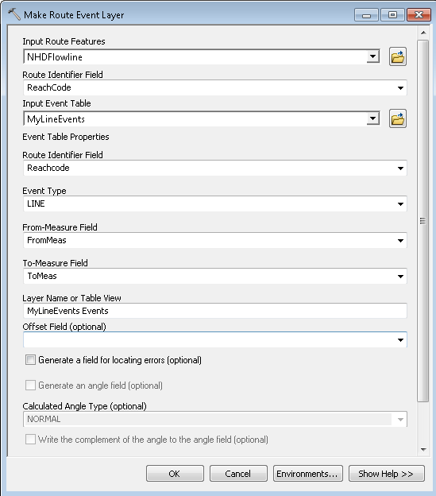

* 1. This creates a temporary layer in the map called MyLineEvents Events. To permanently save the line events with geometry, right click and export the layer to \NHDPlus_H_0206_GDB.gdb\Events\MyLineEvents_Rendered.
  2. Remove all the line and point event tables and layers from the map, leaving only NHDFlowline.

The line and point events can be used to tie external data to the NHD stream network. For example, if the EventID in the point events is a stream gageid, this ID can be used to access the NWIS database to find stream flow measurements. The EventID in the line events can be used to link a database of stream impairments to the stretches of stream represented by the line events.

1. Link Data to Catchments:
   1. Except for catchments associated with Sinks, each catchment is associated with a High Resolution NHDFlowline feature. Therefore, another way to link data to the network is to link the data to catchments.
   2. Any landscape raster data can be used to compute catchment attributes. As an illustration, let’s use the High Resolution NHDPlus elevation grid to compute some elevation statistics for HRNHDPlus catchments.
   3. Open the **Spatial Analyst Tools -**> **Zonal** -> **Zonal Statistics as Table.**

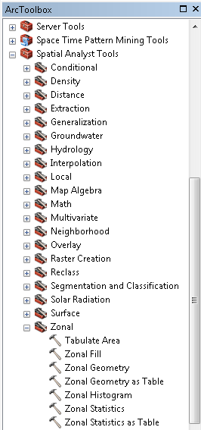

* 1. Populate the **Zonal Statistics as Table** dialog as follows:

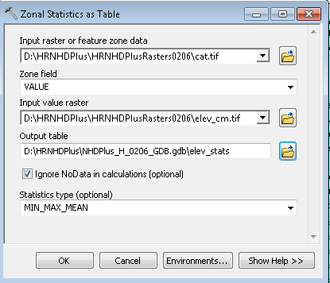

* 1. It’s not always necessary, but it’s always wise to set several environment settings before running Zonal tools. Click the **Environments…** button.

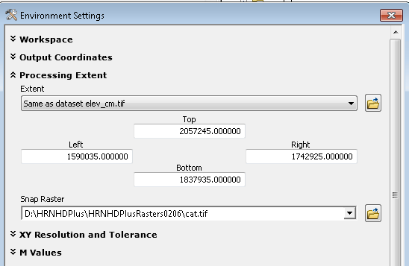

* 1. Press **OK,** then run the tool.
  2. **Add Data** \HRNHDPlus\NHDPlus_H_0206_GDB.gdb\NHDPlus\NHDPlusCatchment to the map.
  3. Join NHDPlusCatchment GridCode with \HRNHDPlus\elev_stats_0206.dbf.VALUE
  4. Double click on NHDPlusCatchment and select the **Properties** -> **Symbology** tab. Select **Quantities-Graduated Colors.** Under **Fields-Value,** select **MEAN.** Set **Classes** to **10** and click **Classify.** In the **Classification** dialog, click **Sampling** and change the default value from **10,000** to **500,000.** Click **OK.** Elevation is expressed in centimeters and the values are large.
  5. Back on the **Symbology** tab, right click on **Color Ramp** and un-check **Graphic View.** Then select **Elevation #2** from the **Color Ramp** drop down.
  6. Note: Attributes like Mean, Minimum and Maximum elevation are just a few of many potential attributes that can be allocated to catchments for useful analysis.

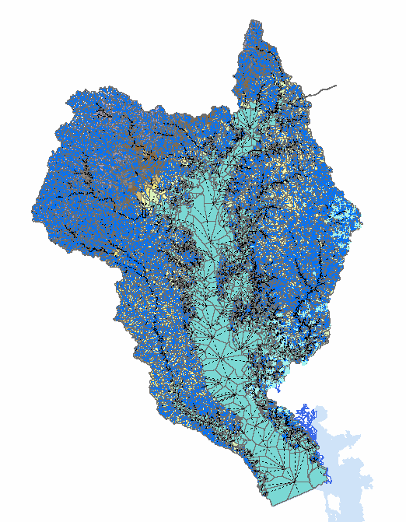

Save the Student5.mxd and close ArcMap.

# **Analyze Linked Data**

1. Open the \HRNHDPlus\Student1.mxd
2. Add linked data to the map:
3. **Add Data** \HRNHDPlus\NHDPlus_H_0206_GDB.gdb\Hydrography\NHDPointEventFC.
4. Open the NHDPointEventFC attribute table and examine the fields. The table below describes the attributes associated with this feature class.

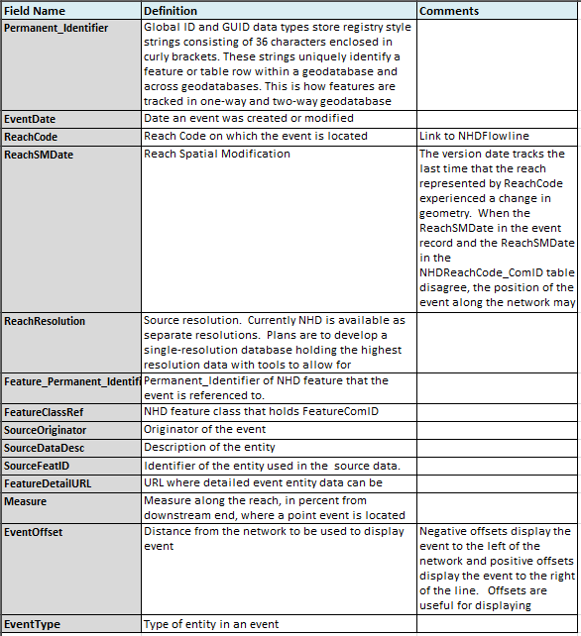

1. Investigate different point events and their attributes.
   1. From the NHDPointEventFC table, perform a select by attributes ReachCode ='02060006004164'
   2. Zoom to the selected events and set the map scale to 1:10,000.

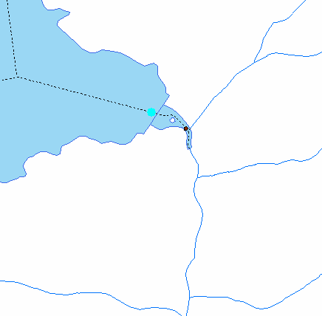

* 1. Perform an Identify on the flowline where the event is located. Note how it shares the same Reachcode as the point event.

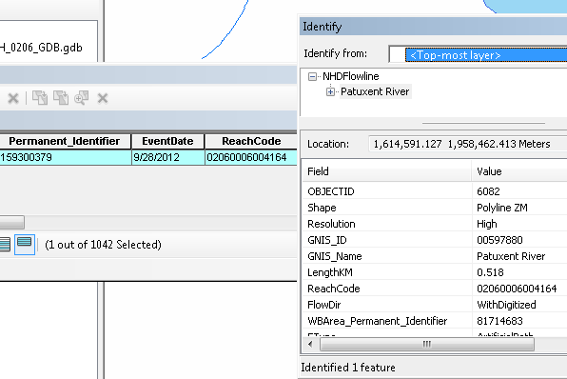

* 1. Now, do an Identify on the point event. Note the EventType is a Dam and the source data description is “Photo Interpretation”.

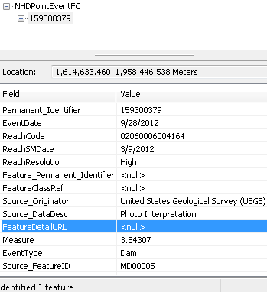

* 1. Let’s take a look at imagery in this area. Click on the pull down arrow on the **Add Data** button. Select **Add Basemap…** and choose Imagery with Labels. Click **Close** on the Geographic Coordinate Systems Warning message.

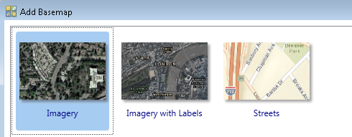

* 1. Turn off all layers except NHDPointEventFC and NHDFlowline. Zoom in so the map scale is around 1:4,000. Notice the imagery and location of the dam.

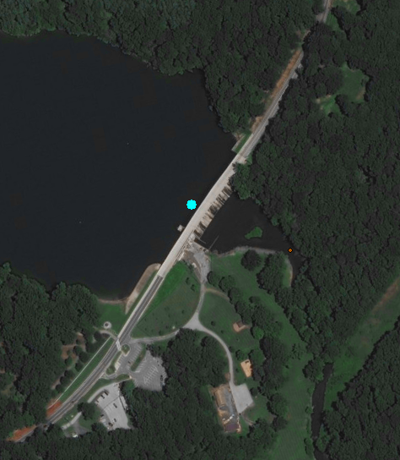

* 1. Turn off the World Imagery layer and add the USA Topo Map basemap. Again, ignore and click **Close** to the Geographic Coordinate Systems Warning message. We now see this point event is Brighton Dam.

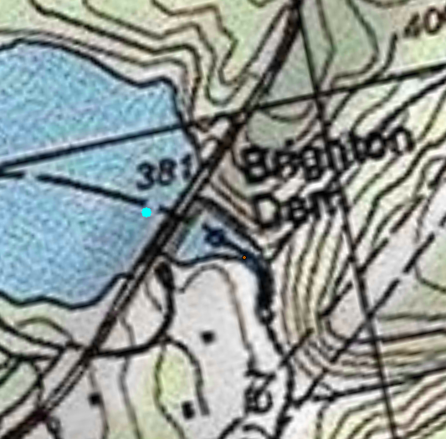

* 1. From the NHDPointEventFC attribute table, select by attributes ReachCode = ‘02060006000192’ (This event is roughly 140 meters southeast of the Brighton Dam.)
  2. Perform an Identify on the selected point. There are actually 2 events in this location:
     1. Streamgage: Streamgage Status=Active; Record=Continuous
     2. Water Quality Station.
  3. In the Identify window, highlight the Streamgage (Permanent_Identifier = 151053400). Notice the Source Data Description is “NWIS, National Water Information System”.

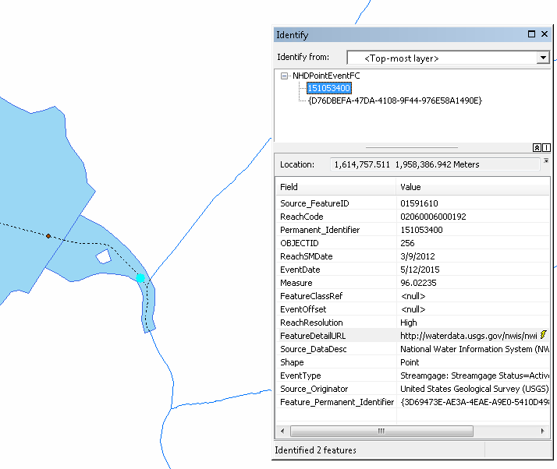

* 1. The **FeatureDetailURL** field contains a link to more information. Click on the URL or copy and paste it into a web browser. This opens the an NWIS webpage that provides information about this stream flow gage.

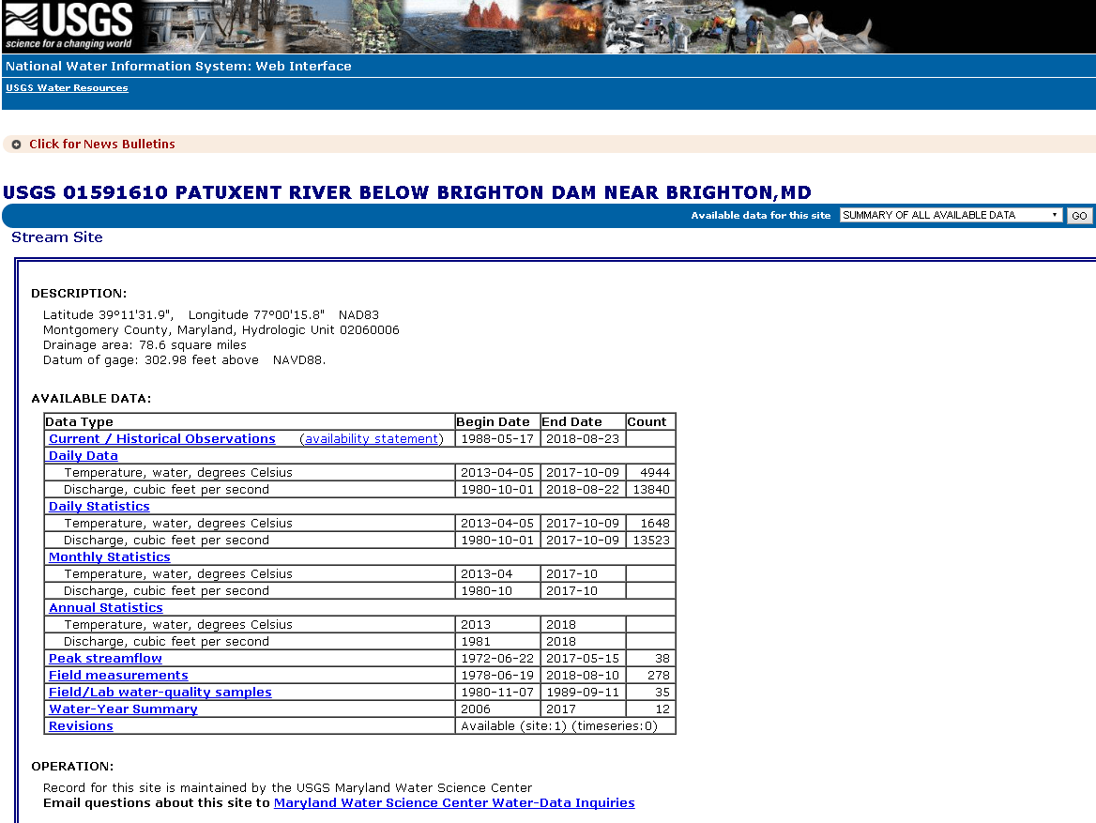

* 1. Explore the available data by clicking different links on the page. Note how the data is available for download in a variety of formats.
  2. Let’s take a look at the monthly water temperature (min, max, mean) and discharge (mean) statistics for the Brighton dam during 2016.
  3. Click on the **Monthly Data** link and fill out the parameters as shown below. Then click **Submit.**

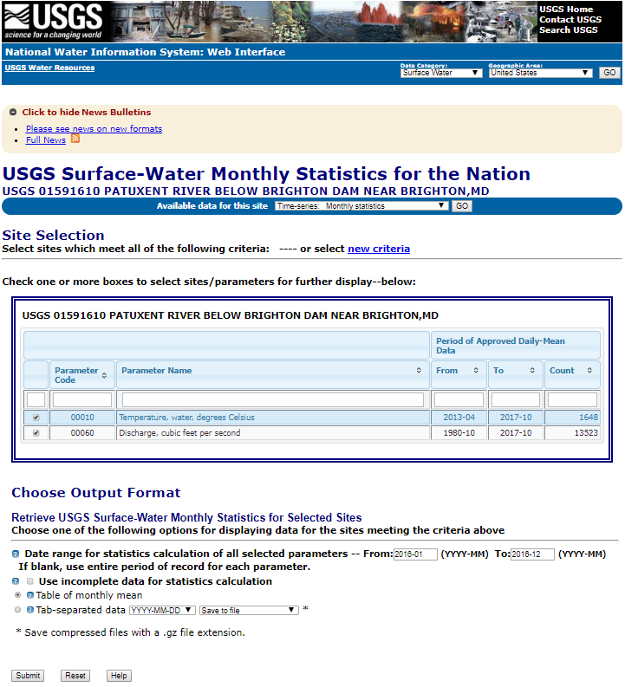

* 1. The display shows the monthly temperature and discharge stats in 2016 for the Brighten Dam. You may also save the data to a tab-separated file which can be opened in Excel and other applications for further analysis.

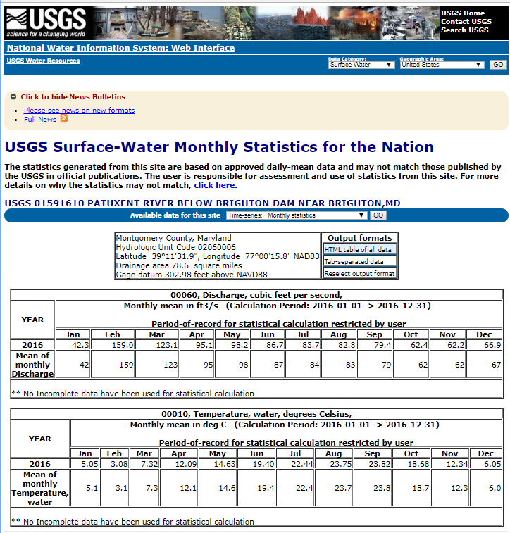

This short exercise illustrates the nearly unlimited capabilities that can be achieved as the water resources community links more and more data to the NHDPlus HR network.

Save the project as Student6.mxd

# **Delineate a Basin/Drainage Area**

The basic steps for delineating a basin are to

* Establish a Pourpoint on a drainage channel defined by the flow accumulation raster,
* Run the ArcGIS Watershed tool to create a basin polygon,
* Optionally, fill holes that represent non-contributing areas,
* If the basin continues in upstream VPU’s, process each upstream VPUs as follows:
  + Navigate the network.
  + Select catchments based on navigation results.
  + Dissolve basin polygon and selected catchments.

1. Create a Pourpoint file:
   1. Open ArcCatalog.
   2. Right click on \HRNHDPlus\NHDPlus_H_0206_GDB.gdb\ and select **New** -> **Feature Dataset…** and call it BasinDel. Set the Coordinate System as GSC_North_American_1983. Click Next and accept defaults for the remaining prompts.
   3. Create a point feature class called MyPourpoints in the BasinDel feature dataset. Then close ArcCatalog.
   4. Open the Student3.mxd and save a copy as Student7.mxd
   5. **Add Data…**

\HRNHDPlus\NHDPlus_H_0206_GDB.gdb\BasinDel\MyPourpoints

\HRNHDPlus\NHDArea.lyr\HRNHDPlusRasters0206\fac and fdr. No need to build pyramids. Turn fac and fdr layers off in **Table of Contents**.

1. Use the **Go To XY** tool on the ArcMap toolbar to zoom to the following coordinates. Then use the **Map Scale** window on the ArcMap Toolbar and zoom in to 1:30,000.

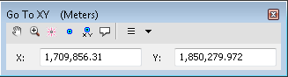

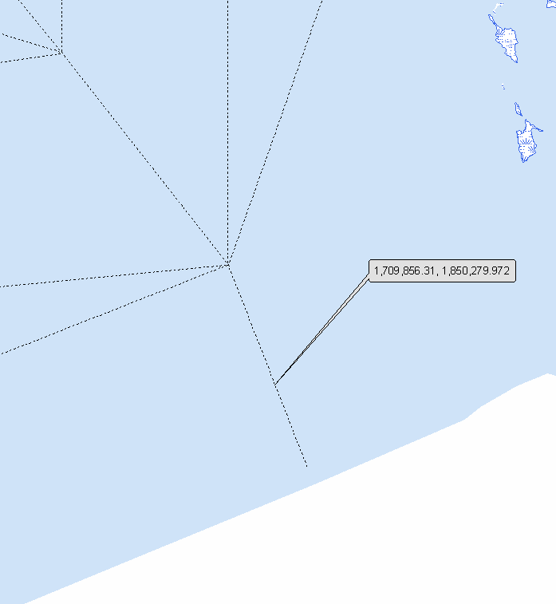

1. Using the **Editor** toolbar, **Editor** pulldown
   1. **Start Editing,** choose MyPourpoints.
   2. **Editor** -> **Editing Windows** -> **Create Features**
   3. In the **Create Features** window, select MyPourpoints.
   4. Under **Construction Tools,** select **Point** and create a point on the network. Save your edits and stop editing. Close the **Create Features** window.

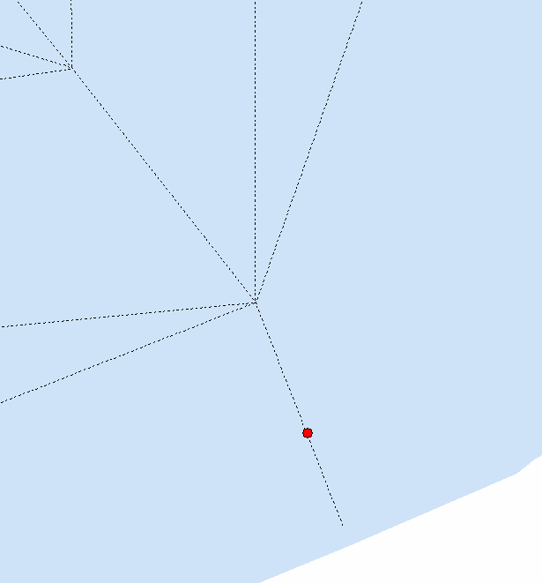

* 1. Use ArcToolbox **Spatial Analyst-> Hydrology->Snap Pour Point** to ensure that the pourpoint is located on a high value FAC cell. Save the output raster as \HRNHDPlus\pourpoint.

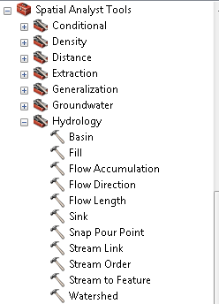

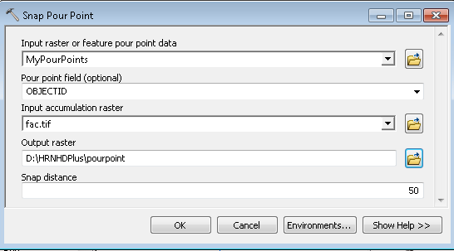

1. Create a Basin Polygon
   1. Use ArcToolbox **Spatial Analyst** -> **Hydrology** -> **Watershed** to delineate the basin. Save the output raster as \HRNHDPlus\watershed.

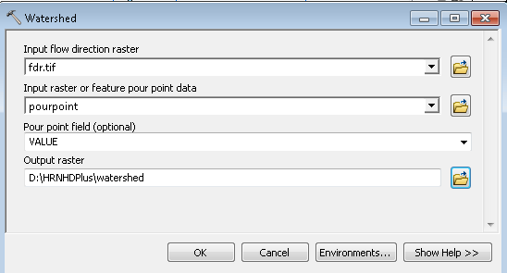

* 1. Note: The Watershed tool will run for about 50 minutes
  2. Zoom to the watershed layer. Turn off the NHDFlowline layer to improve the view.

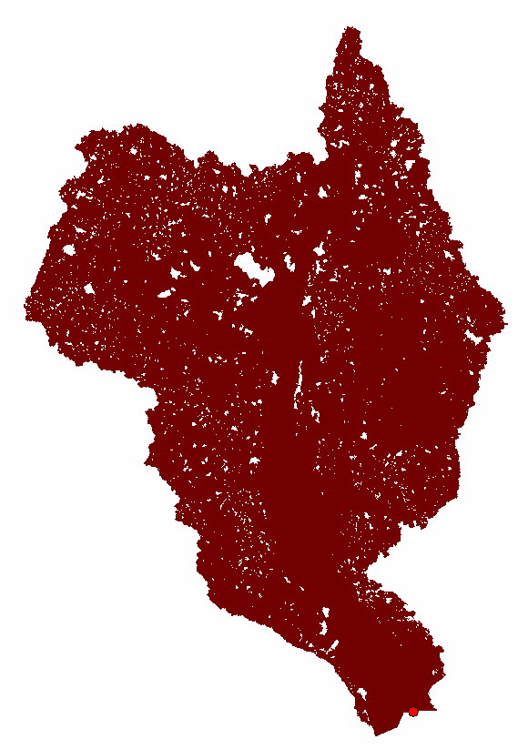

* 1. This basin stops at the top of the VPU boundary. However, the basin should continue into the upstream neighbor, VPU 0205. We will need to add the upstream data to have a full, complete version of the basin. To do this, we’re going to navigate the network upstream from the top of the current basin and gather the NHDPlus catchments to complete the basin.
  2. Use the **Go To XY** tool on the ArcMap toolbar to zoom to these coordinate

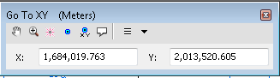

* 1. Then use the **Map Scale** window on the ArcMap Toolbar to zoom in to 1:100,000. Turn on the NHDFlowline layer.
  2. Add \HRNHDPlus\NHDPlus_H_0205\Hydrography\NHDFlowline to the map. Symbolize the layer as you wish, make sure it’s noticeably different from the 0204 NHDFlowline layer.
  3. Add HRNHDPlus\GlobalData\HRNHDPlusGlobalData\BoundaryUnit. Symbolize with no fill and thick green outline. This will help us see the VPU boundaries.

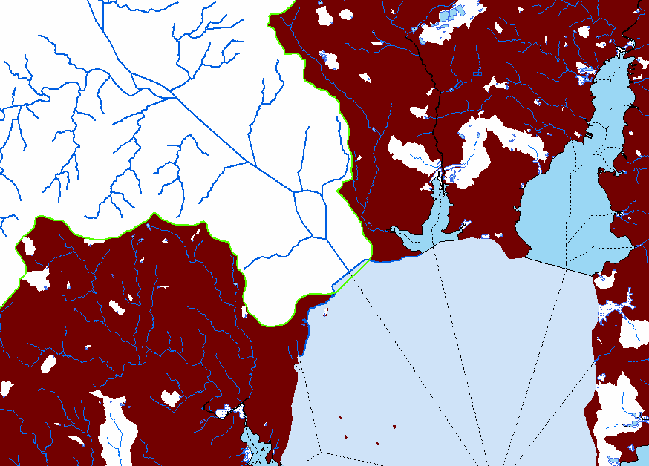

* 1. From the **Utility Network Analyst** Toolbar, use the **Add** **Edge Flag** tool to place a flag just outside of the 0206 basin, ie on the most southern flowline in 0205. From the **Analysis** pulldown, select **Options->Results**. Click on **Return Results As -> Selection**. Select **Trace Upstream** from the **Choose Trace Task** pulldown. Click the **Solve** button.

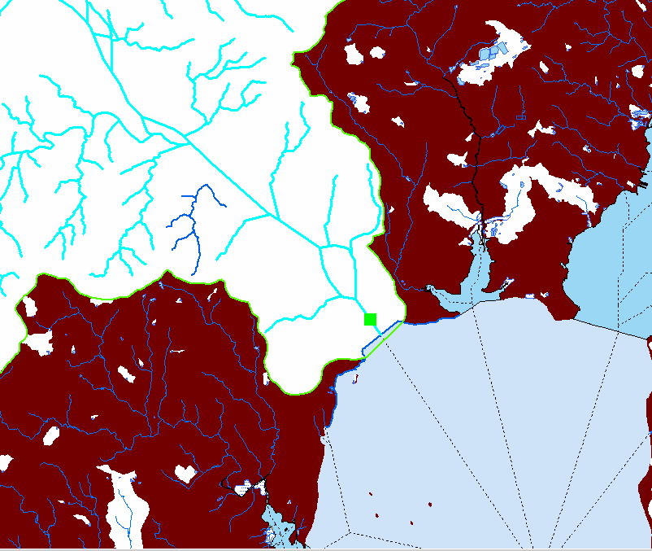

* 1. Zoom to the extent of the selected flowlines.

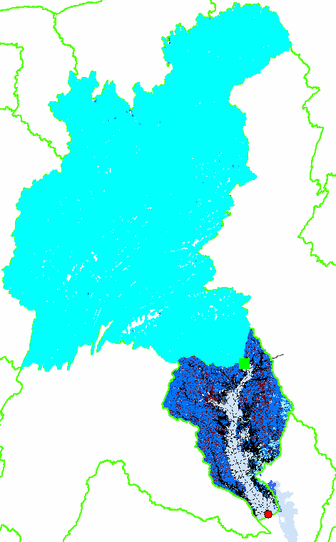

* 1. **Add Data** \HRNHDPlus\NHDPlus_H_0205_GDB.gdb\NHDPlus\NHDPlusCatchment
  2. **Relate** NHDFlowline.NHDPlusID to NHDPlusCatchment.NHDPlusID. Open the NHDFlowline table and execute the Relate. Zoom to the selected Catchments. Right click on NHDPlusCatchment and export selected to NHDPlus_H_0205_GDB.gdb\NHDPlus\BasinTop
  3. In ArcToolbox, use **Conversion->From Raster->Raster To Polygon** to convert the partial basin in 0206 to a polygon called NHDPlus_H_0206_GDB.gdb\BasinDel\BasinBottom

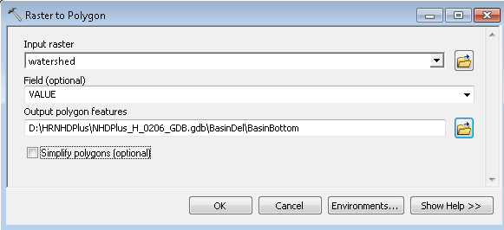

* 1. Using **Data Management->General->Append**, add BasinBottom into BasinTop.

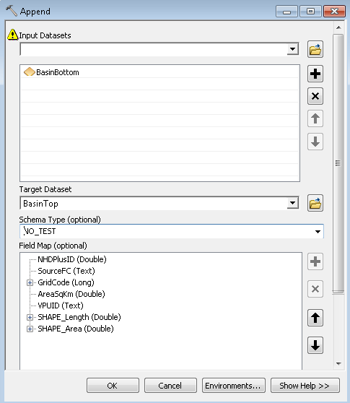

* 1. Using **Data Management->Generalize->Dissolve**, dissolve BasinTop into a single polygon called BasinWhole.

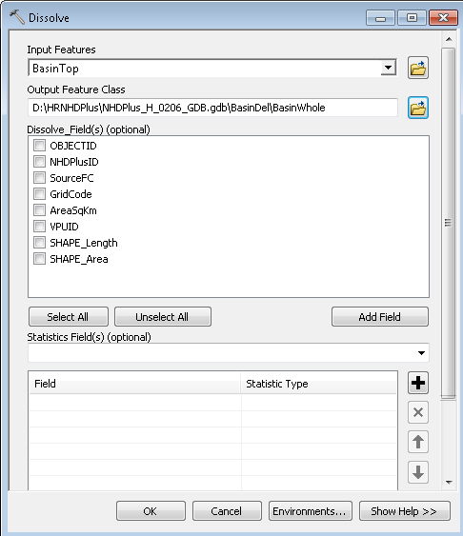

* 1. Note that the basin now contains some holes.

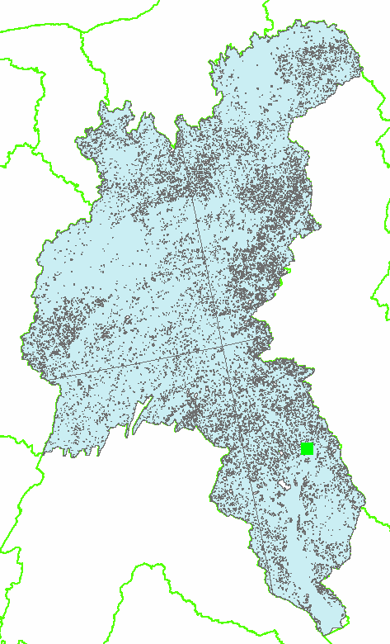

* 1. To get a solid basin, use **Data Management->Features->Polygon to Line** creating BasinLines

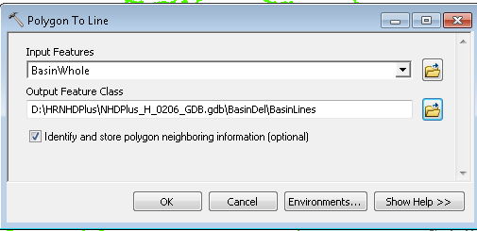

* 1. Use **Data Management** -> **Features** -> **Feature to Polygon,** creating BasinPoly

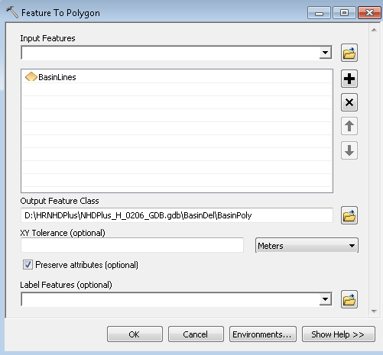

* 1. Finally, use **Data Management** -> **Generalization** -> **Dissolve** to create our final basin called MyBasin.

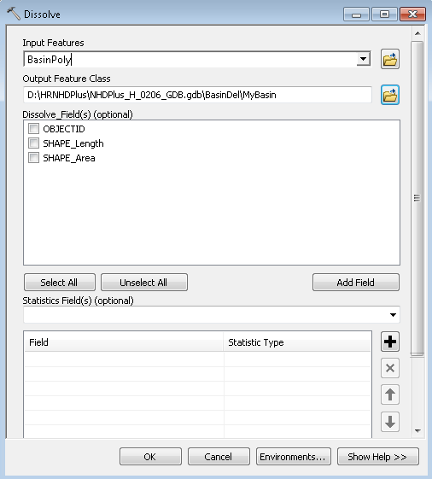

MyBasin should look like the figure shown below.

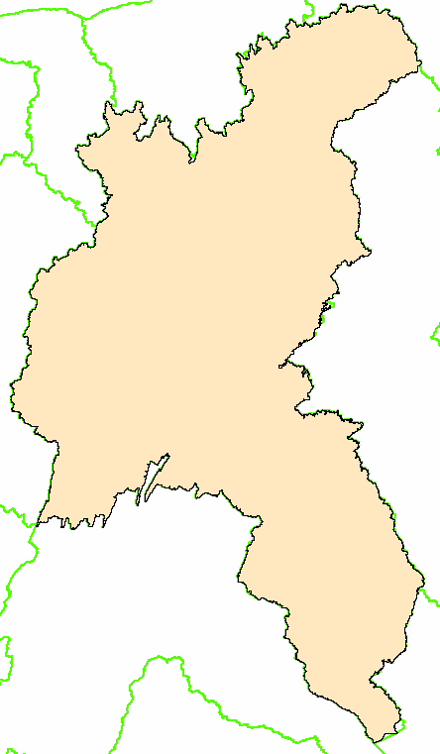

Save the Student7.mxd and close ArcMap.

Basin characterization is another exploration of information that has been linked to the NHDPlus network and catchments.

As a homework assignment see how many attributes you can develop for this basin.

# **High Resolution NHDPlus VAA Navigator – Extra Credit**

The best and most complete way to navigate the NHDPlus network is using the HRNHDPlus VAA Navigator. This tool comes with its own ArcMap toolbar and can also be called from an application you might write in Python. If you anticipate an application that requires navigation, you may want to consider learning about the VAA Navigator.

1. Visit the High Resolution NHDPlus website Tools page. Download the HR NHDPlus VAA Navigator, other required software, install and read the user guide.
2. Follow the instructions for installing the VAA Navigator. After installing, you can access the ArcMap Toolbar and the callable navigator function.
3. Open the Student1.mxd
4. Save a copy of the project as ExtraCredit.mxd
5. Add the HR NHDPlus VAA Navigator Tool bar to ArcMap and dock it. 
6. Zoom to the outlet of the VPU, about 1:200,000 map scale.
7. Click on the **HRNHDPlus VAA Navigator Up Mainstem** button. 
8. Make the NHDFlowline the active layer. Point and click on the southern-most flowline. The **Navigation Options** dialog will appear.

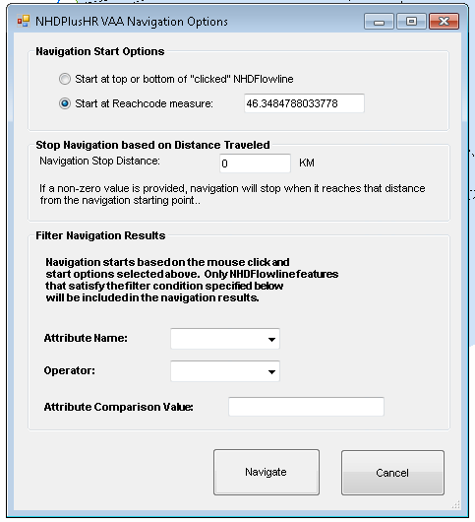

* 1. During the first navigation of a VPU, the navigator will build at SQLlite database that it will use for all future navigations in that VPU. By default, it is created in the same directory as the HRNHDPlus geodatabase. In this case, it will be called HRNHDPlus0206.sqlite.
  2. Click **Navigate** and wait for the **Navigation Results** to appear in the map **Table of Contents.**
  3. Zoom to the **Navigation Results** layer to see the extent of this first navigation.

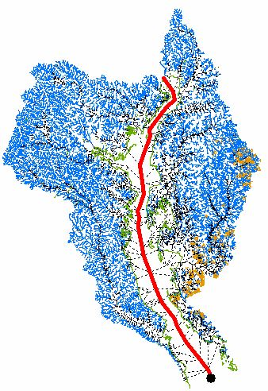

* 1. Click the **Go Back to Previous Extent** button 
  2. Zoom in to the navigation start point (the black dot). Note how the navigation began at the exact point where you clicked on the flowline. This is because we used the default option **Start at Reachcode Measure** in the **Navigation Options** dialog.

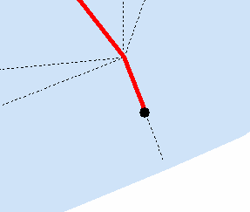

* 1. Using the **Up Mainstem** navigation tool, click on the same spot again and select the **Start at Top or Bottom of “Clicked” NHDFlowline.** Click **Navigate.** Note that this time the navigation includes the bottom of the flowline for upstream navigations. When navigating downstream, this option starts the navigation at the top of the flowline.

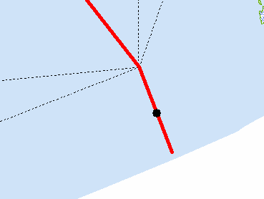

* 1. Right click on **Navigation Results** and open the attributes table. Note that it contains Reachcode, From Measure, To Measure and Hydro Sequence fields. In other words, it’s a line event table.

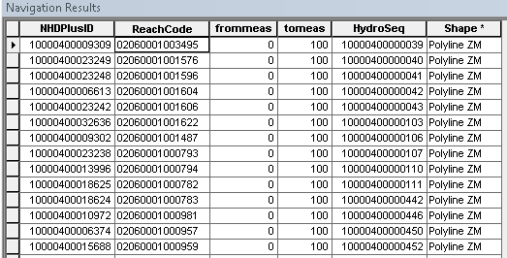

1. Experiment with the other 3 functions of the Navigator. From the same location, run the **Up with Tributaries** tool  and the results should look like this.

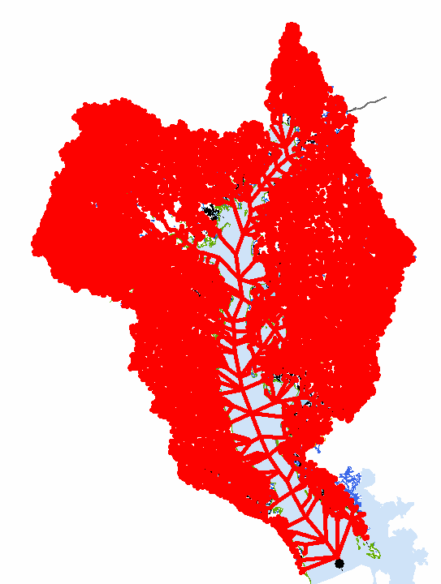

1. Let’s discover stream flow gages along navigation results.
   1. Zoom to the following coordinates: 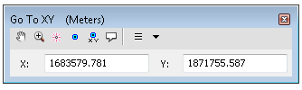
   2. Perform another navigation using the **Up with Tributaries** tool.

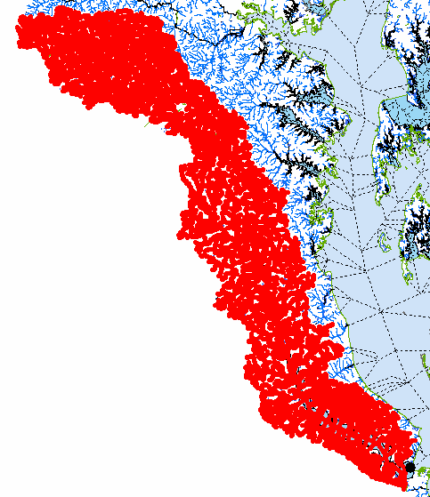

* 1. **Add Data** \HRNHDPlus\GlobalData\HRNHDPlusGlobalData.gdb\GageLoc
  2. Join NHDFlowline.NHDPlusID with NHDPlusEROMA.NHDPlusID
  3. **Right Click** on Navigation Results -> **Data -> Export Data… ->** NHDPlus_H_0206_GDB.gdb\Hydrography\VAANavResults. Note: Once an ArcGIS table or feature class is joined to a layer in a sqlite database, selections cannot be performed on the sqlite data. This is why we are exporting the navigation results, because during the next step, we will perform a join and select by attributes to identify stream gages along the navigation.
  4. Join VAANavResults.Reachcodewith GageLoc.Reachcode.
  5. Select VAANavResults.Reachcode = GageLoc.Reachcode and VAANavResults.FromMease <= GageLoc.Measure and GageLoc.Measure <=VAANavResults.ToMeas. Note that each of the selected flowlines in the VAANavResults are locations of stream flow gages.

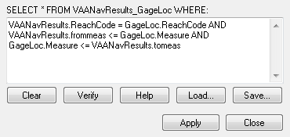

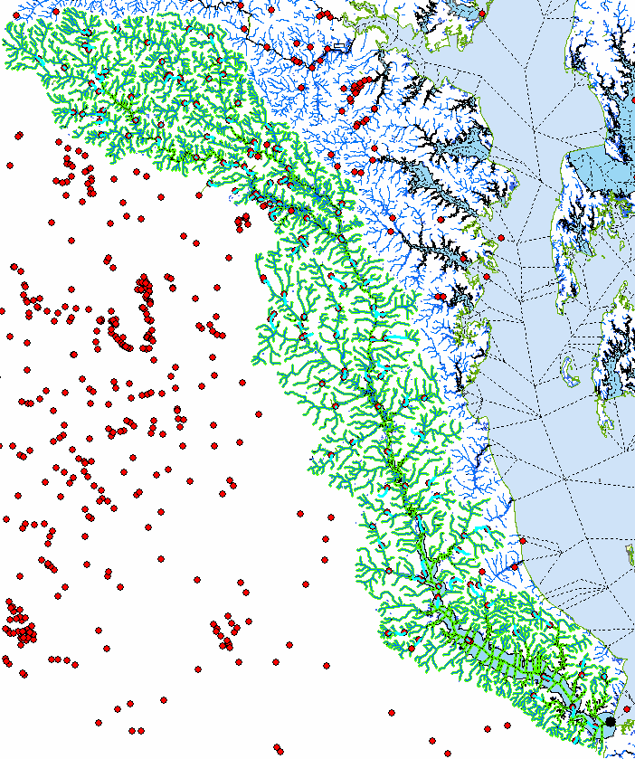

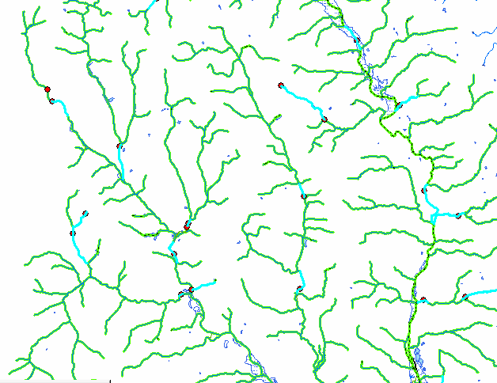

* 1. Join GageLoc.SourceFeatureID with \GlobalData\HRNHDPlusGlobalData\GageInfo.GageID
  2. Label GageLoc with GageInfo.DASQKM in Red text.
  3. Label NHDFlowline with TotalDrainageAreaSqKm.in Blue
  4. Highlight individual selected records in the VAANavResults and **Zoom to Highlighted**.
  5. Compare the red and blue drainage area labels. When the labels have similar values, it’s safe to assume that the gage was used to perform EROM stream flow gage adjustment.

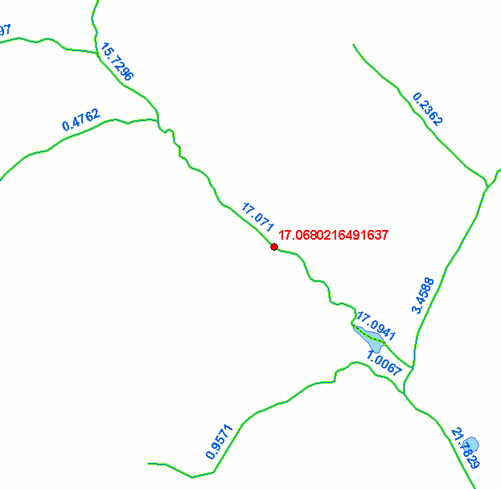

Save the ExtraCredit.mxd